Lego Robot Extravaganza
Come visit Oregon Tech to learn to program a Lego robot and be a part of the Senior Project Symposium! You will complete three challenges:
  - program the bot to stay on the table;
  - avoid crashing into walls;
  - color-match balls.
The event is free. Prizes will be presented to students who complete the challenges!
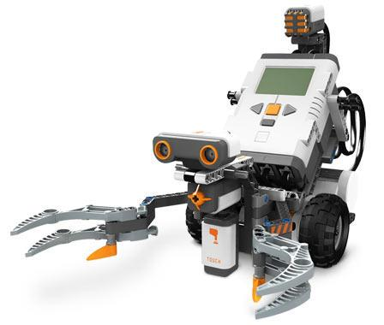
When: Monday, May 20th, from 3 to 6:30pm
Where: Purvine Hall, Room 114
Who: Students from the Klamath Basin, grades 7 and above
What: Participants will visit the Senior Symposium in Purvine Hall from 3:00 - 4:00pm, program a Lego bot from 4:00 to 6:00pm, and participate in a social with drinks and snacks from 6:00 - 6:30pm. For more information, please go to www.oit.edu/epic.

Students are required to present the permission slip below for admission. This event is hosted by students in the EPIC program at Oregon Tech. We and Oregon Tech are not responsible for lost or stolen items. Please leave valuables at home.

