RESOURCE BUDGET PROPOSAL – Klamath Falls

Instructions

Students may submit a Proposal to receive funds for academic projects such as junior or senior projects, annual projects (e.g., SAE Formula or Baja cars), conference travel, or other student-initiated projects. RBC $95,000 total funds to award. Please read these instructions carefully so your proposal is completed properly and reviewed for funding.

STEP 1: Please read the attached document, Oregon Tech Purchasing at a Glance, and take necessary steps
as they apply before submitting your proposal.
STEP 2: Complete Resource Budget Proposal form.
STEP 3: Submit printed or electronic Proposal by January 18, 2018 to the Student Affairs Office (late proposals will not be considered).

PURCHASING GUIDELINES

Donated Materials or Equipment
If you receive any donations related to this Resource Proposal, you must contact Tracy Ricketts, Director of Development at tracy.ricketts@oit.edu or 541-885-1118.

Purchasing and Contracting Requirements
If your project is awarded resource funds, you will be required to complete the applicable procurement process based on the dollar amount of the purchase. Please see the attached Oregon Tech Purchasing at a Glance document for information on required processes.

Klamath Falls Process:
- Computer, software and hardware requests must be approved in advance by ITS and will have to comply with the Dell computer standardization unless an exception has been granted. Please contact Scotty Hayes at scotty.hayes@oit.edu

- Although you will use quotes in the development of your budget, do not assume that if awarded funds, we can direct buy from that vendor. Please do not have vendors provide discounts or offer equipment donations on their quotes, this will not provide an adequate estimate for your proposal. Applicable procurement processes will be required.

- If your request requires any type of installation or connections (even electrical plug in), you must get the sign off from Facilities in advance. Please submit a facilities Work Order Request via MyOIT.

- Please provide an itemized budget for the requested funds

- Conference travel – Food for participant(s) will not be covered.

Please consider contacting Leticia Hill at leticia.hill@oit.edu or 541-885-1133 during the development of your proposal. Leticia can provide advice and guidance to help ensure that your project progresses smoothly if awarded funds.

KLAMATH FALLS CAMPUS
RESOURCE BUDGET PROPOSAL

Form

Individual Name: |  | Department or Group:
Click here to enter text. |  | Click here to enter text.
Project Name: |  | Faculty/Staff Name:
Click here to enter text. |  | Click here to enter text.
Email Address: |  | Phone Number:
Click here to enter text. |  | Click here to enter text.
Please list ALL funding for project below: |  |  | Index
Total requested: | $Click here to enter text. |  | Click here to enter text.
Funds from department: | $Click here to enter text. |  | Click here to enter text.
Oregon Tech Foundation funds: | $Click here to enter text.
Funding from other sources: | $Click here to enter text. |  | Click here to enter text.
TOTAL proposal amount: | $Click here to enter text. |  | Click here to enter text.
Please check all that apply:
☐ Current Budget Attached (required)
☐ Donated Materials/Equipment
☐ Facilities Staff Reviewed/Approved Equipment Installation (required for new equipment purchases)
☐ ITS Reviews/Approved computer software (required for computer software/hardware purchases)
☐ One Time Request
☐ Partial Funding is Acceptable
Specify partial funding priorities (provide funds for specific parts rather than other parts):
Group Advisor or Academic Dean Approval (will also accept email note of approval):
Signature: |  | Date:

In response to each question, please provide adequate explanations so anyone not in your field can understand the project. The area will expand as you type.

1. Describe the student project for which funding is requested.
2. Describe the needs and impact of funding for this student project request.
Click here to enter text.

3. Who will be involved in the project and who is responsible for implementation?
Click here to enter text.

4. What are the dates of completion and implementation?
Click here to enter text.

5. What are the expected outcomes, project goals, and objectives?
Click here to enter text.

6. Other resources for this project? (Provider, In-Kind, or Other Donated Items)
Click here to enter text.

7. What groups and/or individuals have been consulted regarding project purchase and implementation?
Click here to enter text.

8. Please address any safety issues related to this project.
Click here to enter text.

9. What are the benefits to Oregon Tech students as a result of this project? How many students will benefit from the completion of this project? How so?
Click here to enter text.

SUBMISSION
Resource Budget Proposal form deadline (include supporting materials such as budget and emails):
5:00 pm on January 18, 2018 to Student Affairs: CU 217 (Klamath Falls) or rachel.winters@oit.edu

Oregon Tech Purchasing At A Glance

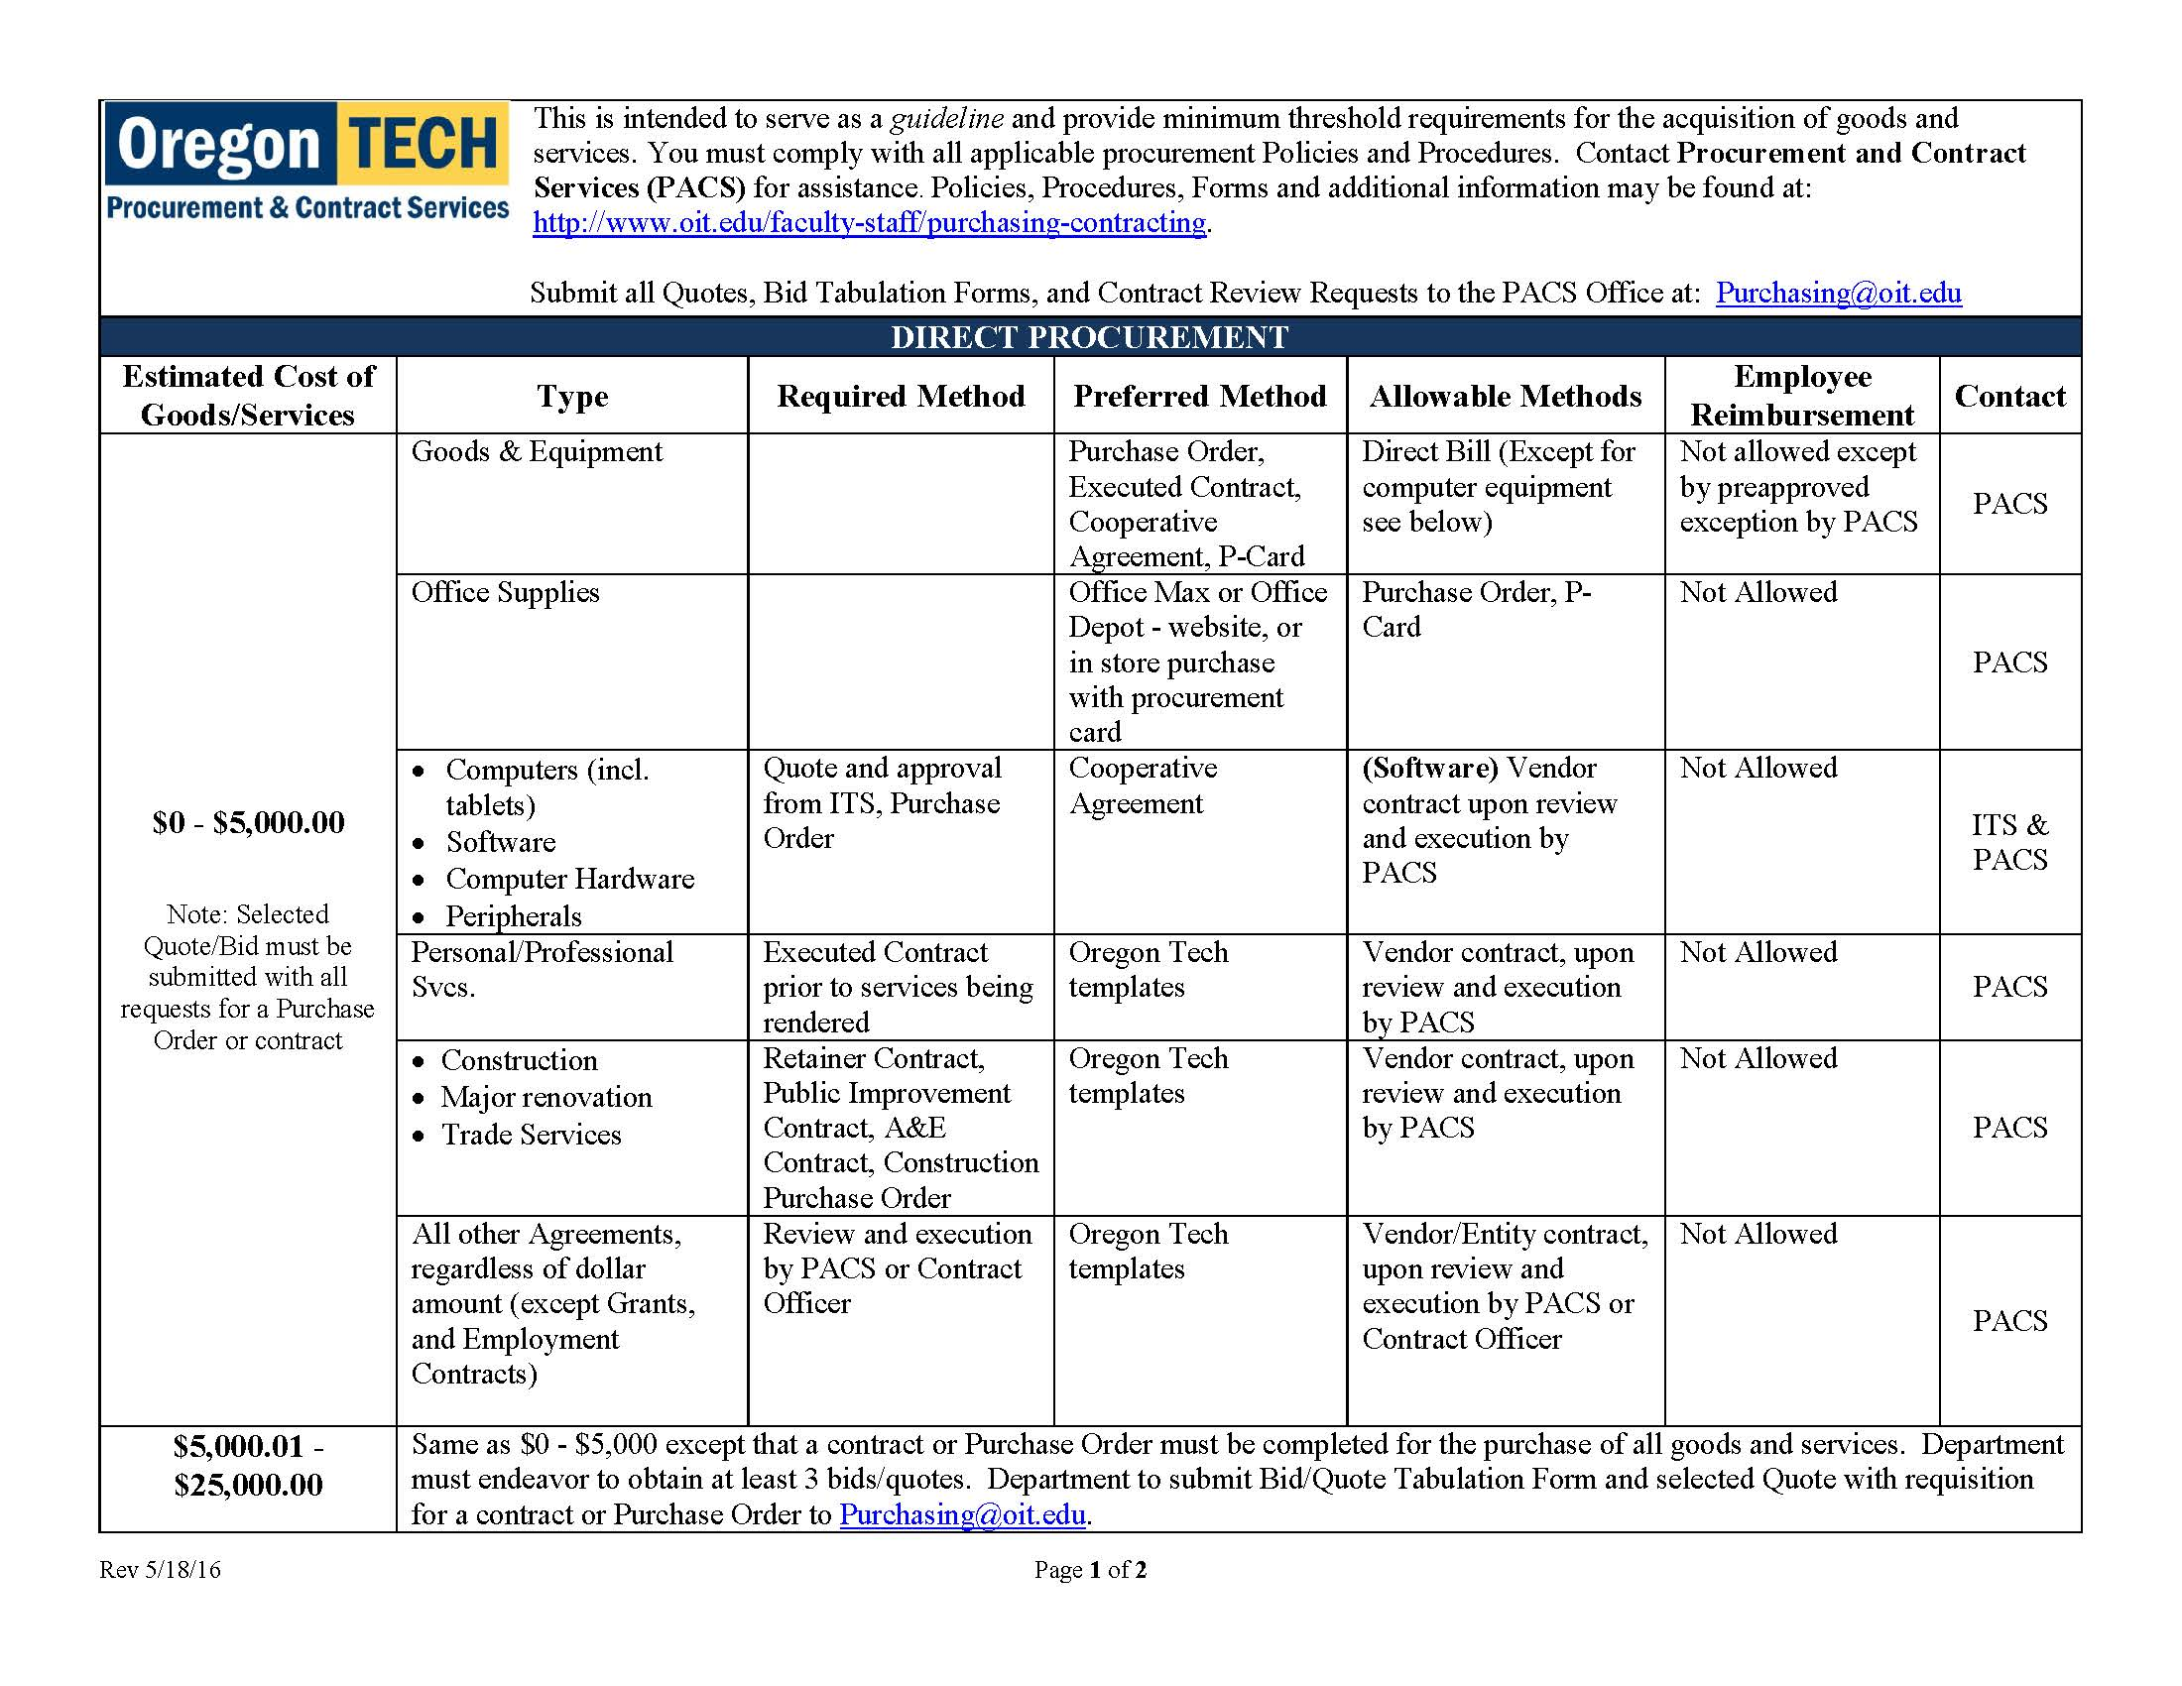

Oregon Tech Purchasing At A Glance
