Kevin Pintong
Kevin.pintong@oit.edu
Abstract
Pre-release guide
Owlboard jr
Assembly and programming

Generously sponsored by:
and the Oregon Institute of Technology Commission on College Teaching.

Contents
Introduction 1
Warning 1
OwlBoard Jr. 3D Views 1
Owlboard Jr. Schematics 1
Owlboard Jr. Layout 1
Owlboard Jr. Bill of Materials (BOM) 1
Component descriptions 1
Assembly Notes 1
Software 1

Figure 1 Front & back 3D view 1
Figure 2 OwlBoard Jr front and rear PCB 1
Figure 3 DIP 28 socket for microprocessor 1
Figure 4 Breakaway 0.1" male headers 1
Figure 5 3mm LEDs 1
Figure 6 8 MHz crystal oscillator 1
Figure 7 push button 1
Figure 8 PIC32 MX250F128B in DIP-28 package 1
Figure 9 330 Ohm resistor 1
Figure 10 10k ohm resistor 1
Figure 11 AMS1117 3.3V linear regulator 1
Figure 12 1uF tantalum capacitor 1
Figure 13 10uF tantalum capacitor 1
Figure 14 Linear regulator location 1
Figure 15 Crystal Oscillator 1
Figure 16 LED silkscreen polarity 1
Figure 17 Fully assembled Owlboard Jr. 1

Introduction
The owlboard JR is based on the reference design and source code used in the ‘DIY ChipKit board’. It is programmable
http://chipkit.net/diy-chipkit-board

Features:
- Uses 32-bit PIC microcontroller PIC32MX250F128B in SPDIP-28 package with preprogrammed bootloader.
- USB connector built into PCB for easy programmability (Detected as a stk500 programmer.
- Increased PCB thickness for USB connector (2.0mm)
- 19 GPIO pins

Warning
In order to build the OwlBoard Jr, you will be using soldering equipment, solder, and flux. Soldering equipment will be extremely hot. Solder and flux may contain hazardous substances such as lead.
It is advised that the participant:
- Exercise caution when soldering
- Wear personal protective equipment (PPE) such as safety glasses
- Use fume extractors to reduce participant exposure to solder fumes

Oregon Institute of Technology and affiliated parties disclaim all liability from injuries, whether emotional or physical, caused by participation in this workshop.
Due to continuous improvement, the shape and components of the OwlBoard Jr may change. Functionality may also change.

OwlBoard Jr. 3D Views
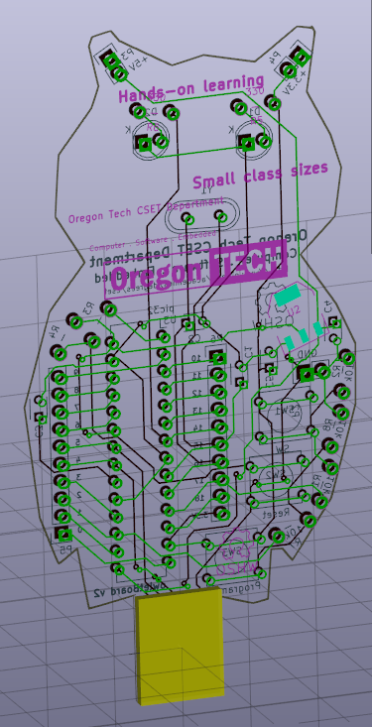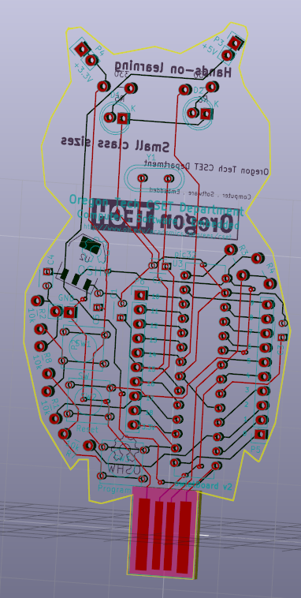
Figure 1 Front & back 3D view

Owlboard Jr. Schematics
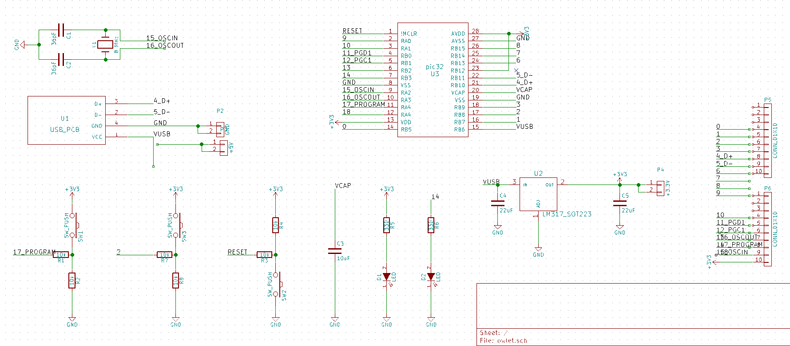

Owlboard Jr. Layout
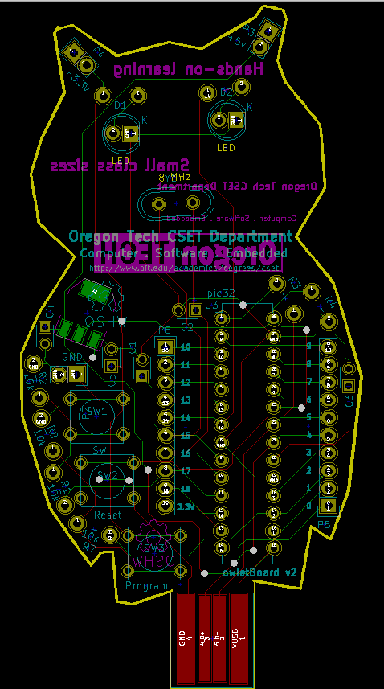

Owlboard Jr. Bill of Materials (BOM)

Table 1 Bill of Materials for OwlBoard Jr
Bill of Materials (BOM) for Owlboard Jr
Line Item | Description | Footprint | Reference | Quantity
1 | Button | through hole | SW1,SW2,SW3 | 3
2 | Resistor 10k | through hole | R1,R2,R3,R4,R7,R8 | 6
3 | Resistor 330 | through hole | R5, R6 | 2
4 | 3mm or 5mm LED | through hole | D1,D2 | 2
5 | Crystal Oscillator 8 MHz | HC-49 | Y1 | 1
6 | Capacitor 1uF (105) | through hole | C4,C5 | 2
7 | Capacitor 3.6pF | through hole | C1,C2 | None required
8 | Capacitor 10uF (106) | through hole | C3 | 1
9 | PIC32 PIC32MX250F128B | 28-pin DIP | U3 | 1
10 | 3.3V linear regulator | SOT-223 | U2 | 1
11 | 10x1 0.1" header | through hole | P5,P6 | 2

Component descriptions

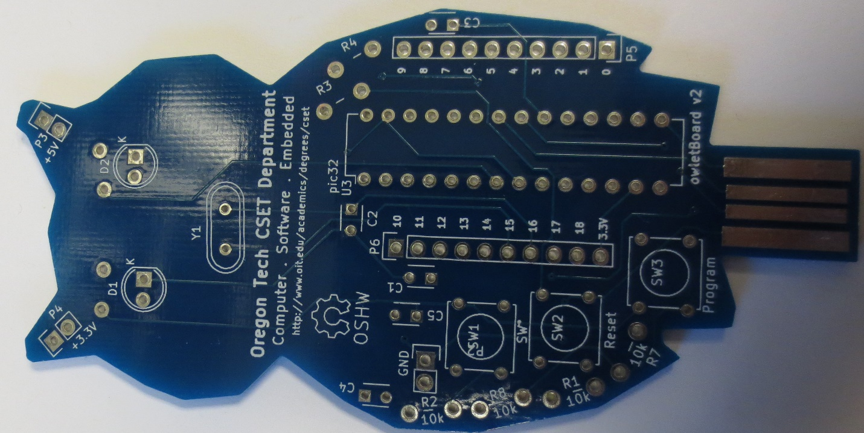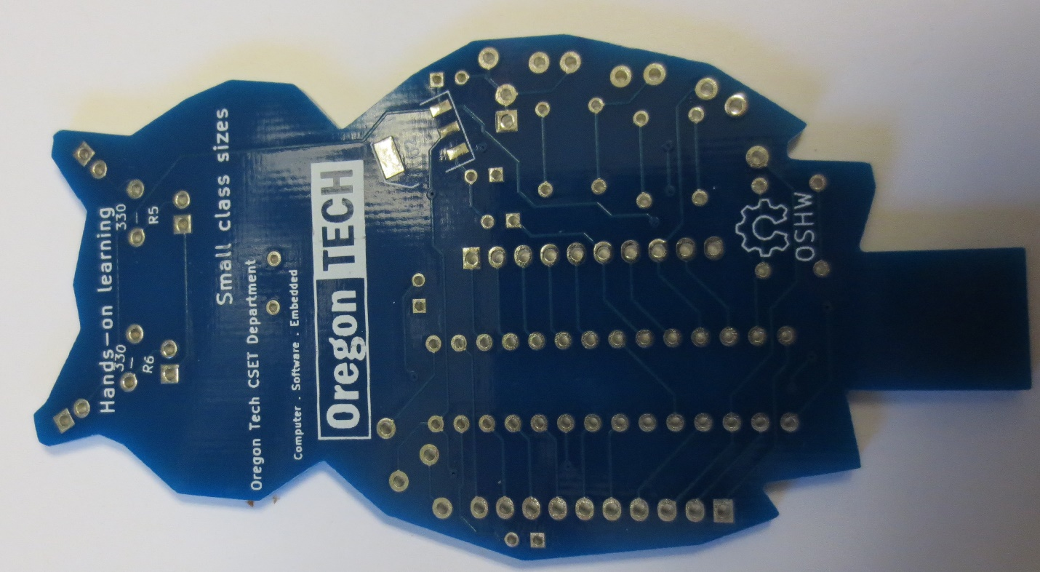
Figure 2 OwlBoard Jr front and rear PCB
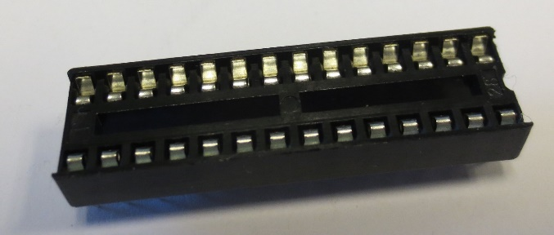
Figure 3 DIP 28 socket for microprocessor
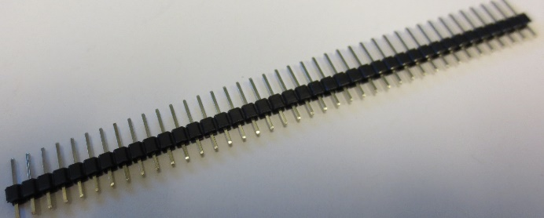
Figure 4 Breakaway 0.1" male headers
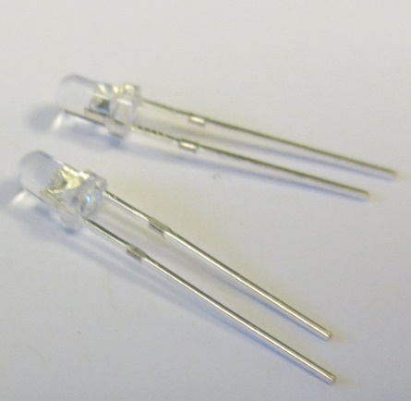
Figure 5 3mm LEDs

Figure 6 8 MHz crystal oscillator
Figure 7 push button
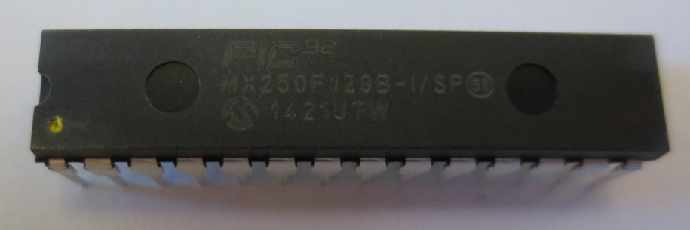
Figure 8 PIC32 MX250F128B in DIP-28 package
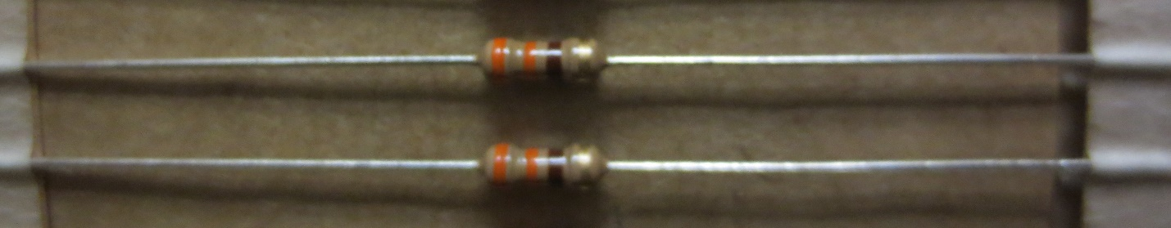
Figure 9 330 Ohm resistor
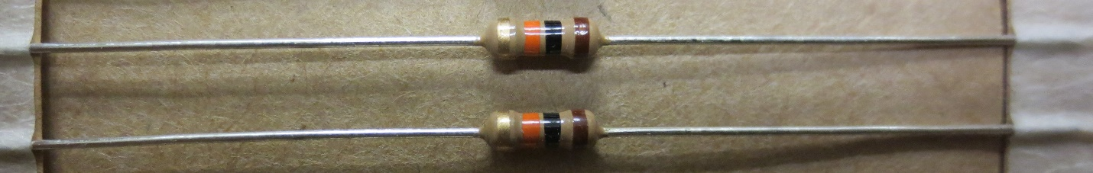
Figure 10 10k ohm resistor
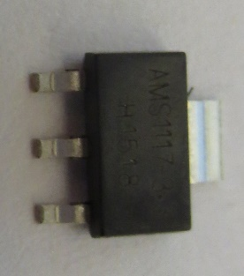
Figure 11 AMS1117 3.3V linear regulator
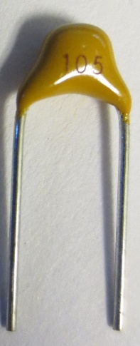
Figure 12 1uF tantalum capacitor
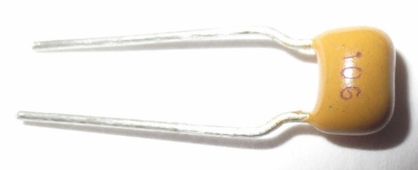
Figure 13 10uF tantalum capacitor

Assembly Notes
Resistors, capacitors, connectors, sockets on this design are non-polarized. You may insert them in any direction.
PIC32 microprocessor must be oriented as shown in Figure 17 Fully assembled Owlboard Jr. The yellow dot must be oriented towards D1.
Buttons will only fit in one direction. Do not attempt to force the button into the other orientation.
Linear regulator must be oriented such that you are able to read the text ‘AMS1117’ when it is placed onto the back of the owlBoard Jr. Assure that you can also see ‘3.3’ on the regulator.
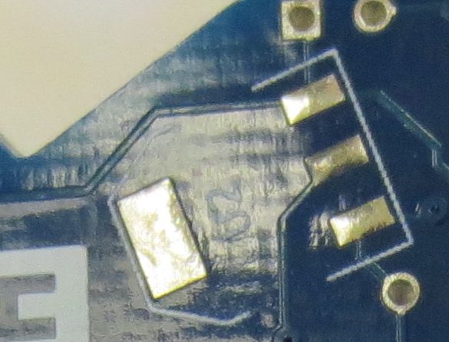
Figure 14 Linear regulator location

Verify that the crystal oscillator is an 8 MHz crystal oscillator before placing onto the board
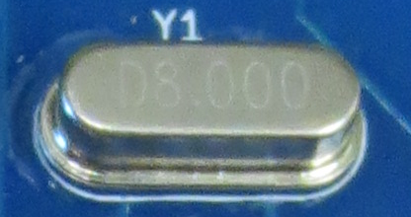
Figure 15 Crystal Oscillator
LEDs are polarized. Please make sure to insert the flat side of the LED to match the flat side of the silkscreen on the board as indicated in Figure 16 LED silkscreen polarity.
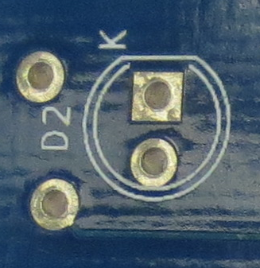
Figure 16 LED silkscreen polarity
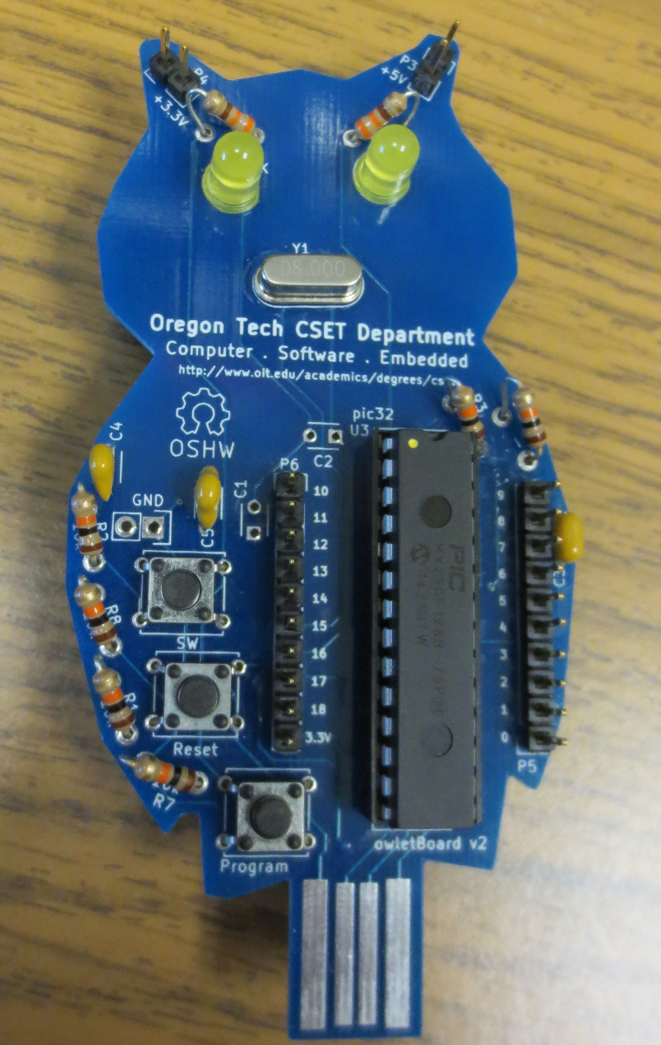
Figure 17 Fully assembled Owlboard Jr.

Software and Programming

Development environment installation
We will use the Arduino compatible development environment designed for Microchip PIC32 products. Download MPIDE for Windows, MAC, or Linux.
Download the software and install it by navigating to this link and installing the MPIDE for your operating system.
http://chipkit.net/started/install-chipkit-software
Extract it to a location of your choice. Note that the driver for the owlBoard Jr. is located in the drivers folder of the zip file.

Board driver installation
Warning! Before plugging in your board, ensure that there are no shorts or bridges.
When plugging in your board, D2 should start rapidly blinking, and your computer should detect something similar to the window below. It should indicate a stk500v2 compatible device. If it does not find a driver, please install the driver from the drivers folder of MPIDE.
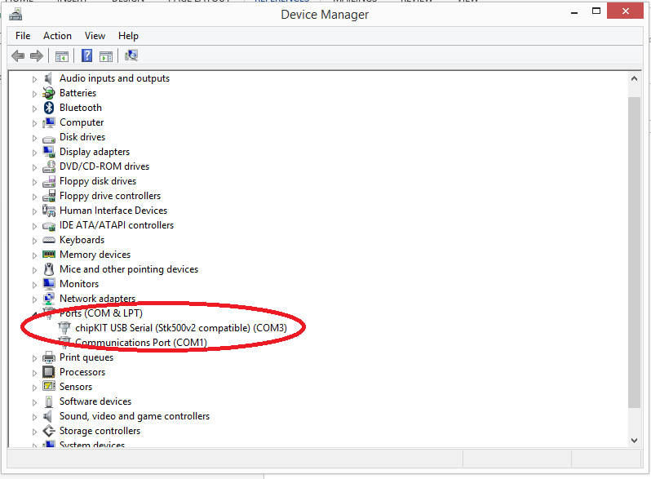
Figure 18 Device Manager Stk500v2

Launch MPIDE

Navigate to the extracted folder and launch MPIDE.
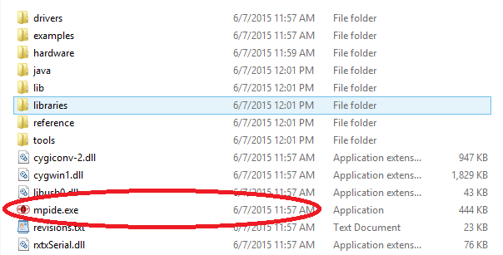
Figure 19 Launch MPIDE

Verify that the DP32 board is selected. This board most closely matches the owlBoard Jr.

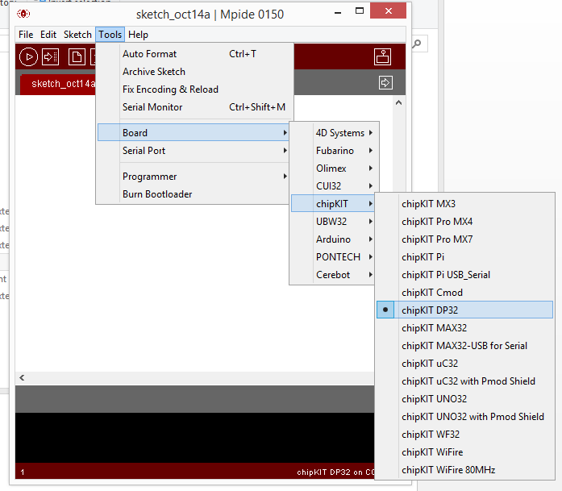
Figure 20 Verify DP32 is selected

Verify that the correct COM port is selected.
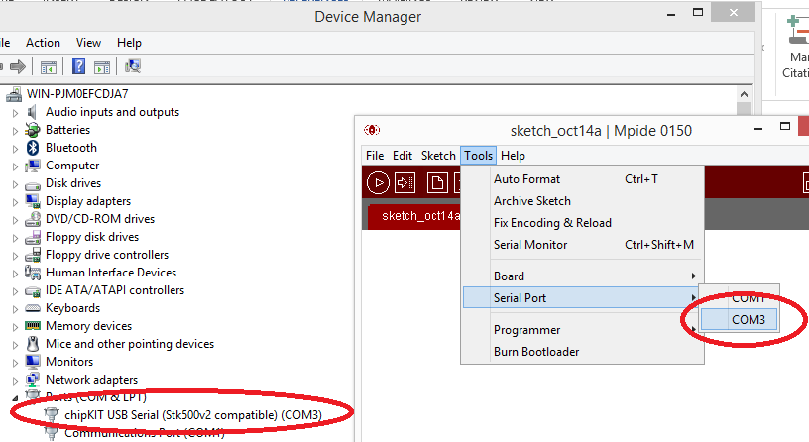
Open the Blink Example.
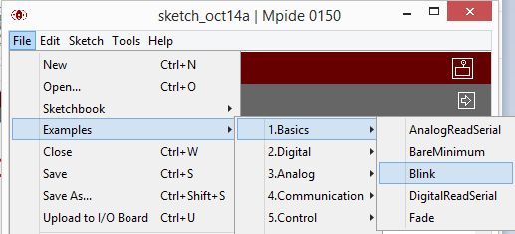
Figure 21

Modify the delay to change the blinking rate.
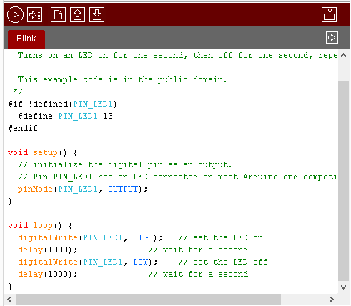
Figure 22
After modifying your code, Verify the correct board and COM port is selected. Click the arrow button. Once the upload is complete, the IDE window should indicate that it is done uploading.
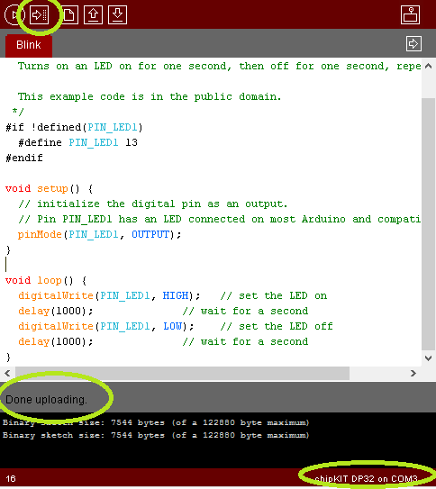
Figure 23

Tutorial Complete

This is a preliminary draft copy.
Please send updates, comments, and suggestions to:kevin.pintong@oit.edu

Thank you for participating in the Oregon Tech owlBoard Jr. outreach project.
This project is sponsored by Microchip and the Oregon Tech Committee on College Teaching.

