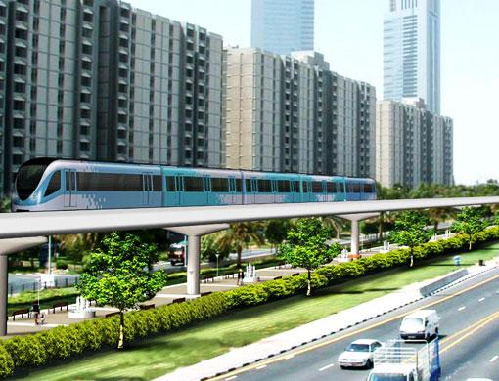
Assignment #2
PSU/OTREC Transportation Seminar Series

The Oregon Transportation Research and Education Consortium (OTREC) co-sponsors a weekly seminar series on Fridays from 12-1. The seminars are streamed live on the internet for “real time” viewing and are also archived for “best time” viewing. The website is http://www.cts.pdx.edu/seminars/index.php.

You are encouraged to view as many of the seminars as you can, but as a minimum course requirement you will view the following four seminars that I feel are most closely related to CIV573.

Oct 2 | Creating a City of Cyclists: What We Can Learn from Copenhagen | Niels Jensen, City of Copenhagen Traffic and Road Department

Oct 16 | Urban Form and Traffic Safety: Examining the Design and Developmental Factors that Influence Crash Incidence | *Eric Dumbaugh, Texas A&M

Oct 23 | Economic Value of Walkability | Joe Cortright, Vice President/Economist, Impresa, Inc.

Nov 13 | Transportation and Land Use Modeling | *Joan Walker, UC Berkeley

After attending each required seminar, please email me a short summary of the seminar which focuses on the “3 big ideas” that you took from each speaker. The summaries are to be included in the text of the email (please NO ATTACHMENTS).

Due: Each summary due 5pm Friday one week following.

