2017-18 Academic Year
&
2018 Summer Session
Fee Book

Oregon Institute of Technology
3201 Campus Drive
Klamath Falls, OR 97601

The Fees and Tuition were approved by Oregon Tech Board of Trustees at the May 8, 2017 meeting. However, the contents of the fee book were not approved by the Oregon Tech Board of Trustees. All prior Academic Year and Summer Session Fee Books are repealed except as to rights and obligations previously acquired or incurred thereunder.

Introduction
It is the Board Policy on Tuition and Fee process of Oregon Institute of Technology that tuition, fines, fees and other charges are to be developed, approved, issued and communicated in a consistent manner, with the engagement of appropriate University stakeholders. The purpose of the Board’s Tuition and Fee Policy is to outline and clarify the process for setting tuition, fines, fees and other charges at the University.

This Fee Book contains policy statements and delegation of authority for a variety of University policies and fees and is published for public information.
With the passage of Senate Bill (SB) 270 (2013) and effective July 1, 2015 Oregon Institute of Technology will set their own tuition and fee rates under the governance of their own institutional boards.
As part of the implementation of Senate Bill 242, passed in June 2011, each institution was required to establish a process which integrated student participation in the tuition-setting process in accordance with Board adopted processes. Oregon Tech is in compliance with these guidelines.

Delegation of Authority
The Oregon Legislature grants authority to the Oregon Institute of Technology Board to establish tuition and fees for enrollment at Oregon Tech. Based on recommendations from the Student Tuition Committee, Tuition Recommendation Committee, Health Advisory Committee, Incidental Fee Committee, and the President of the University, the Board annually sets fees for enrollment at the institution, including:
- Tuition
- Building Fees
- Health Service Fees
- Incidental Fees
- Other Mandatory Enrollment Fees
- Other Special Fees as determined by the Board
The Board has delegated authority to the Presidents to establish certain fees, fines, and charges for services and materials, including:
- Laboratory and Course fees
- Fees for workshops
- Instruction fees for Continuing Education, Extended Programs, and Distance Education
- Residence Hall Room and Board Rates
- Charges for auxiliary services, e.g., food services, student centers, and parking
- Fines for violation of campus regulations
- Charges for facilities use
- Charges for other materials and services
The schedule of charges is on file in the business office of the institution and also filed with the Vice President of Finance and Administration. Income from such services must be reflected in the institution budget.
As amended by SB 270 (2013), the Board may not increase the total amount of enrollment fees paid by undergraduate resident students by more than five percent annually unless the Board first receives approval from the Higher Education Coordinating Commission (HECC) or the Legislative Assembly. Oregon Tech and the Board have complied with this requirement.

Tuition and Fee Policies for 2017-18

Tuition Structure and Assessment
Tuition rates for students admitted to academic programs are established via student classification (undergraduate and graduate), residency, and credit hours taken. Tuition revenue supports all facets of the university operations including the instructional and administrative costs of the institution and varies based on factors including class sizes, faculty salaries, specialized programs and equipment as well as facilities required to teach courses. Nonresident students should pay a larger share of instructional costs than resident students when the market allows and, on average, cover the full cost of instruction. Nonresident rates should be competitive with those charged at peer institutions and be sensitive to the institutional nonresident enrollment trends and objectives.
There are three basic tuition and fee structures at Oregon Tech: the regular academic year, summer session, and continuing education programs. Under existing policy, each of the three tuition structures is separate, with its own unique rate setting process. The Academic Year and Summer Session tuition and fees are set by the Board and Continuing Education rates are set by the President.
Academic Year:
- Charges assessed to students during the academic year are comprised of Tuition, Mandatory Enrollment Fees, One-time Fees, and Other Student Fees. The revenue generated by each component is dedicated to a specific purpose, independent of the other components. Enrollments during the academic year are usually referred to as “in-load” enrollments.
Summer Session:
- As with the academic year, tuition supports the direct instruction and administrative costs of each institution’s summer session programs. For summer session programs, tuition may be assessed on a per-credit hour basis or aligned to the preceding academic year’s structure. Institutions are not required to make a residency determination for summer term but may choose to do so. Tuition rates in the summer session may differ from the academic year and may or may not vary based on residency status.
Continuing Education:
- Continuing Education, Extended Programs, and most Distance Education courses fall within the category previously referred to as self-support. Continuing Education courses are offered through special campus programs not generally available during the academic year or summer session. Tuition and fees for Continuing Education are assessed regardless of residency or course load. Rates are set at levels necessary to cover (at a minimum) the direct costs of providing the course plus an indirect cost recovery for administrative overhead costs. Tuition and fees are charged to participating students apart from enrollment fees paid for other courses. Assessment of Resource Fees for Continuing Education courses is an institutional decision.
UG/GR Combination Courses:
- A resident student is one who fulfills Oregon residency requirements as established by the Comprehensive Agreement (see Student Residency below).
- A nonresident student is one who does not meet Oregon residency requirements as specified in the Comprehensive Agreement.
- Students who enroll in a combination of undergraduate and graduate courses in excess of 6 credits are assessed tuition and fees based upon their residency for each respective classification. i.e. if a nonresident student takes 4 undergraduate credits and 3 graduate credits for a total of 7 credits, they will be charged for 4 undergraduate credits at the nonresident rate and 3 graduate credits at the nonresident rate.

Process for Setting Tuition and Fees

Tuition and Mandatory Student Fees are established annually by the Board, generally at the Board’s meeting in March prior to the applicable academic year. When setting Tuition and Mandatory Student Fees, the Board considers a number of factors, including state‐appropriated funds, financial need of the University, market factors, the mix of students, students’ wellbeing and financial constraints. The Board’s consideration of Tuition and Mandatory Student Fees will be based on the recommendation of the President. As outlined in the Board Policy, the President shall establish a process for student participation in the development of the recommendation, which is to include, at a minimum, the ability to receive input from the Student Tuition Committee and ASOIT, which is outlined in the Board Policy.

Student Residency
A resident student is one who fulfills Oregon residency requirements as established by the Comprehensive Agreement. Oregon residency is generally based on the following criteria: a person with a bona fide fixed and permanent physical presence established and maintained in Oregon of not less than 12 consecutive months immediately prior to the term for which residence status is requested. State funded graduate students who become Graduate Teaching or Research Assistants are automatically converted to resident status for fee purposes.
A nonresident student is one who does not meet Oregon residency requirements as specified in the Comprehensive Agreement.

Fees
Fees fall into three distinct categories: Mandatory Enrollment Fees, One-time Fees, and Other Student Fees. At Oregon Tech, academic or administrative units begin the process for requesting a new fee or revising an existing fee by preparing a fee proposal and submitting it to the appropriate university administrator for review and approval.
The fee requests must include information regarding the academic unit initiating the fee, fee designation or name, justification of need, amount, estimated revenues and expenditures, and expected implementation date. All fee proposals are thoroughly reviewed by university administration, tuition incidental fee committee, ASOIT, and the President have to agree on incidentals before being submitted to the Board for final assessment and adoption into the Academic Year and Summer Session Fee Book.

Limits on Tuition and Mandatory Student Fee Increases

When setting Tuition and Mandatory Student Fees, the Board shall consider the following limits:

The Board may not increase the total of Tuition and Mandatory Student Fees by more than five percent (5%) annually unless the Board first receives approval from the Higher Education Coordinating Commission (HECC) or the Legislative Assembly.

The Board will attempt to limit annual increases in Tuition and Mandatory Student Fees to a percentage that is not greater than the percentage increase in the Higher Education Price Index, as compiled by the Common-fund Institute.

Mandatory Enrollment Fees
Mandatory enrollment fees include Building, Health Service, and Incidental. Students enrolled under the part-time student fee policy are subject to these fees at a rate appropriate to the specific number of credit hours taken each term. Institutions have the option of assessing mandatory enrollment fees during the summer session at rates comparable to those assessed in the academic year.
Building Fee:
- The Building Fee is set by each institution per their Board Policy. This fee is established by legislative statute and allows the universities to assess up to $45 per student per term to finance debt service for construction associated with student centers, health centers, and recreational facilities constructed through the issuance of Article XI-F(1) bonds. The fee charge for summer session is approximately 75% percent of the academic year rate. For summer, the rate is $34 per student. A pro rata fee is assessed on part-time students.
Incidental Fee:
- Incidental fee recommendations are made by student committees on each campus. The student committee recommendations are supported by general campus student referenda. Funds generated by incidental fees are used to fund student union operations, educational, cultural, and student government activities, and athletics.
- It is a joint recommendation by the President, ASOIT, and the incidental fee committee for establishing incidental fees for the subsequent year. Once approved, presidents submit recommendations to the Board. Generally, there are fewer incidental fee supported activities during the summer term, resulting in lower rates than those assessed during the academic year.
Health Services Fee:
- This fee is used to support each institution’s student health services, and is reviewed by the Health Services Advisory Committee with a recommendation to the ASOIT and OIT President. These are operated as an auxiliary enterprise on a self-sustaining basis. During summer sessions, student health services operations may function at reduced levels or are not provided at all. The recommended summer session rates reflect these reduced service levels.
One-time Fees
The Matriculation and Transcript fees are examples of one-time fee charges to new or transfer students. These fees are one-time assessments and were developed to reduce the large number of enrollment-related fees for student orientation, course scheduling (drop/add fees), transcripts, degree applications, and re-enrollment. The fees are also used to support academic programming for freshman interest groups and learning.
- Other Student Fees
Fees for Instruction Related Services:
- Laboratory and Course Fees must be published in the institution’s catalogue and/or time schedule of classes. Laboratory and Course Fees are limited to institutional sale to students of equipment, materials, or ancillary services consumed by the student as a part of course instruction where the equipment or material is not readily available for purchase through the bookstore or other external source.
Approval will not be given for Laboratory and Course Fees that constitute a charge for the use of institution owned equipment, specimens, software licenses, or other microcomputer application charges for goods or services, or other materials and supplies consumed in the instruction process, except for certain non-required physical education courses that involve use of non-state-owned facilities or expensive equipment.

Fees and Fines for Non-Instruction Related Services and Materials:
- The Board Policy requires that the level of charges be sufficient to ensure recovery of the cost of providing the services and materials as well as to recover the indirect costs associated with these activities. These include charges for auxiliary services, e.g., housing, food services, student centers, parking, and bookstores; charges for facilities use; etc. Institutions also set the level of fines for violation of campus regulations, such as late fines for library books, parking fines, etc.
Application Fee
- Oregon Tech may determine the amount of the application fee (up to $100.00) and establish policies governing the conditions under which application fees will be required. Oregon Tech may assess additional application fees for admission to selected programs or schools within their institution. In instances where an application is received without the Application Fee, request will be made for the Application Fee, and the fee must be received before the application will be evaluated. Application Fees are not refundable.
Application Fee Deferral Program
- Institutional executives may, upon request, defer the Application Fee for first-time freshmen or transfer students who, at the time of application, are either eligible for or participate in any of the following:
- Free or reduced school lunch program;
- TRIO-type college preparatory programs (e.g., Upward Bound, Talent Search, EOC, HEP);
- State of Oregon or U.S. public assistance; and/or
- College Board fee waiver
- Foster Youth Tuition and Fee Waiver
To request an online application for Application Fee deferral, go to the following web address located at: http://www.oit.edu/docs/default-source/admissions-documents/deferral-of-application-fee-for-admission.pdf?sfvrsn=2. The student must complete the deferral form and have it signed by a school official (high school counselor), special program official, or University official, and submit it at the time of application. Application fees deferred under this provision become payable upon the student’s enrollment and receipt of financial aid funds. If a student does not complete the application process or does not enroll, the Application Fee is canceled. Students residing outside the United States at the time of their application must prove to the satisfaction of institutional officials that they would meet comparable eligibility guidelines in their country of residence.
- Part-time Fee Policy
Part-time Fee Policies apply to students enrolled for up to six academic year credits in a term. The part-time fee policy does not differentiate residents from nonresident students in tuition assessment. Students may take additional credits through Continuing Education courses.

- Fee Remissions.

Tuition rates set by the Board do not preclude the President or designee from establishing and applying fee remissions towards the cost of tuition.

Post baccalaureate, Non-graduate Student Classification
A holder of an accredited baccalaureate degree who has not been admitted to a graduate degree program and who submits an official application for admission to pursue a second baccalaureate degree or enroll in course work not to be used for graduate credit is called a post baccalaureate, non-graduate student and is assessed tuition at undergraduate rates.
Fees and policies applicable under the part-time fee policy shall prevail when a student classified as a post baccalaureate, non-graduate enrolls for six or fewer credits at Oregon Tech.
Baccalaureate degree holders who are admitted to post baccalaureate, non-graduate status at undergraduate tuition rates are precluded from claiming graduate credits for graduate courses taken while in this status. However, Oregon Tech may allow the reservation of not more than six of their graduate credits per term to apply in their institution’s graduate programs. Graduate credits reserved in combination as an undergraduate and post baccalaureate, non-graduate cannot exceed 15 credits. Baccalaureate degree holders who are not admitted to post baccalaureate, non-graduate status will be assessed graduate tuition rates.
Students who are admitted to an advanced degree program may convert to post baccalaureate, non-graduate student status only if the graduate degree has been awarded, if a student has been dropped from the degree program by the institution, or upon a request approved by the dean of the Graduate School for voluntary relinquishment of graduate status.

Reduced Tuition Policies
Oregon Tech’s commitment to 40-40-20 is achieved through an array of innovative reduced tuition programs and policies. These programs and policies promote Oregon Tech’s goals of providing accessibility to higher education by assuring college is affordable and relevant to the realities of today’s student population.

Approved Programmatic Student Financial Aid Programs
Student financial aid programs are funded through institutional resources. The policies governing each program specify the extent to which the enrollment fees are to be reduced. The combined total aid for a student may not exceed the total enrollment fees for that student.
Oregon Tech’s student financial aid offerings are comprised of programs similar to others offered across the country (often referred to as “fee waivers”, “tuition discounts” or “tuition remissions”) enhanced by innovative initiatives specific to the state of Oregon. The objective of programmatic student aid programs is to provide financial incentives for certain student groups to enroll. As an enrollment management tool, programmatic student aid allows an institution to target specific campus enrollment goals including recruitment of needy or meritorious students, international students, athletes, and other student populations. The following are summaries of Oregon Tech student financial assistance programs:

Diversity Programs
- Oregon Tech Educational Diversity Initiative
Criteria: This program is open to all students, resident or nonresident, undergraduate or graduate. The program may consider different factors in making awards and may offer one or more tuition and fee remission programs as long as it maintains its commitment to diversity. Under these guidelines, Oregon Tech may consider different factors in support of their educational mission.
Awards: Rather than a prescribed allocation of funds for educational diversity fee remissions, Oregon Tech has the discretion to determine the remittance amount and allocation schedule. Oregon Tech may make partial or full waivers based on need or to expand the number of students who receive at least some funding support. Awards are not transferable. Students may not take a tuition remission with them if they move to another public university, but will be evaluated based on the receiving school’s educational diversity needs.

International Cultural Service Program
- International Fee Remission Program
Criteria: This program is for undergraduate or graduate students with foreign student status.
Awards: Awards may vary in amount but cannot exceed the total nonresident undergraduate or graduate Enrollment Fees (Tuition, Building, Incidental, and Health Service Fees). However, the institution has the option to remit these fees if they see fit.
b. Cultural Service Program
Criteria: This program is for undergraduate or graduate students with foreign student status who: are competitively selected on the basis of academically meritorious achievement; and fulfill the community service requirements of the program while receiving the award.
Awards: Awards may vary in amount but cannot exceed the total nonresident undergraduate or graduate Enrollment Fees (Tuition and Mandatory Enrollment Fees). Remission of Mandatory Enrollment Fees is at the institution’s option.

International Exchanges
a. International Exchange Program
Criteria: This program is for students who are attending Oregon Institute of Technology as a part of an approved system-wide exchange program.
Awards: Awards may consist of remission of all or some of the Enrollment Fees, depending upon the reciprocal agreement under which the student is enrolled.
b. International Institution Exchange Program
Criteria: This program is for students who are attending Oregon Institute of Technology as a part of a Board-approved institution exchange program.
Awards: Awards may consist of remission of all or some of the Enrollment Fees, depending upon the reciprocal agreement under which the student is enrolled.

Contract and Grant
a. Contract and Grant: Academic Year
Criteria: This provision is for students who participate in specific courses or programs during the academic year funded by grant or contract with an outside agency or firm.
Awards: Awards are generally for remission of Tuition only, depending upon agreement with the granting agency.
b. Contract and Grant: Summer Session
Criteria: This provision is for students who participate in specific courses or programs during the summer session funded by grant or contract with an outside agency or firm.
Awards: Awards are generally for remission of Tuition only, depending upon agreement with the granting agency.

Oregon Tech Supplemental Tuition Grant
Criteria: The Oregon Tech Supplemental Tuition Grant is a need-based tuition grant program available to qualified Oregon resident students.
Awards: These supplemental tuition grants may vary at institutional discretion but may not exceed the total Tuition assessed for the regular academic year.

VOYAGER Fee Remission
The Voyager Tuition Assistance Program (Voyager) was implemented in the Fall of 2005 in response to a direct gubernatorial request and is intended for National Guard and Reservists who have been in an area of hostility since 9/11.
Criteria: The VOYAGER fee remission is for Oregon residents (Comprehensive Agreement) who are members of the National Guard or Reserves and were deployed in an area of military combat since September 11, 2001. This fee remission is for full-time students pursuing their initial bachelor’s degree. Students must submit a Free Application for Federal Student Assistance (FAFSA) annually and continue to maintain satisfactory academic progress to maintain eligibility.
Awards: Award is the difference between the National Guard and Reserves tuition benefit of $4,500 and total enrollment fees. Students are responsible for securing the National Guard or Reserves tuition benefit. Duration of the VOYAGER award is four years excepting those five-year degree programs as documented in the campus general catalogs. Students may not earn more than 15 credits above the minimum number of credits required by the degree to maintain eligibility.

Veteran’s Dependent Tuition Waiver
Criteria: The Veteran’s Dependent tuition waiver is for qualified students accepted into a baccalaureate or master’s degree program at a public university.
A qualified student is a child (includes adopted child or stepchild), spouse, or an un-remarried surviving spouse of a service member or a child of a Purple Heart recipient.
The service member is one who:
- Died on active duty;
- Has a 100% total and permanent service-connected disability rating as certified by the United States Department of Veterans Affairs; or
- Died as a result of a military service-connected disability.
The Purple Heart recipient is a person, alive or deceased, who:
- Was relieved or discharged from service in the Armed Forces of the United States with either an honorable discharge or a general discharge under honorable conditions; and
- Was awarded the Purple Heart in 2001 or thereafter for wounds received in combat.

An eligible child must be 23 years of age or younger at the time the child applies for the waiver. A child who is older than 23 years of age is eligible for a waiver for a master’s degree program if the child:
1) Applied for and received a waiver for a baccalaureate degree when the child was 23 years of age or younger; and
2) Applied for a master’s program waiver within 12 months of receiving a baccalaureate degree.
The qualifying new, transfer, or community college co-enrolled student must meet Oregon residency requirements as stipulated within Comprehensive Agreement, which generally describes an Oregon resident as a person with a bona fide fixed and permanent physical presence established and maintained in Oregon of not less than 12 consecutive months immediately prior to the term of entry.
Awards: The award may be granted for credit hours for courses that are offered at an eligible post-secondary institution. The award does not cover other mandatory enrollment and course specific fees. The maximum waiver granted under this remission program shall be:
1) The total number of attempted credit hours equal to four years of full-time attendance for a baccalaureate degree; and
2) The total number of attempted credit hours equal to two years of full-time attendance for a master’s degree.
Notwithstanding sections 1 and 2 of this paragraph, a waiver may not exceed the total number of credit hours the qualified student needs to graduate with a baccalaureate or a master’s degree. Transferred credit hours accepted for a degree program may or may not count toward the total credit hours needed for degree completion.
The amount of tuition waived may be reduced by the amount of any federal aid scholarships or grants, awards from the Oregon Opportunity Grant program established under ORS 348.205, or any other aid from the eligible post-secondary institution, received by the qualified student.
The amount of tuition waived may not be reduced by the amount of any Survivors’ and Dependents’ Educational Assistance under 38 U.S.C. Chapter 35 paid to a qualified student.
Awards to children of Purple Heart recipients apply only to students admitted as new but not continuing for Fall 2013 or thereafter.
Statutory Authority: ORS 350.285 Waiver of tuition for family members of deceased veterans; limits on waiver; conditions

Nonresident Veteran Fee Remission
As required by Law, every public university shall participate to the fullest extent allowed in the federal educational assistance programs under the Supplemental Appropriations Act of 2008 (e.g., Post 9/11 G.I. Bill and its component Yellow Ribbon Program), so as to reduce the overall tuition rate for students eligible under this policy.
Criteria: The Nonresident Veteran Fee Remission is a tuition and fee reduction for qualified students who are attending classes as an admitted undergraduate or graduate at a public university, and who meet one of the following sets of criteria:
- Is not an Oregon resident and:
  - Served in the Armed Forces of the United States;
  - Was relieved or discharged from that service with either an honorable discharge or a general discharge under honorable conditions as shown on an original or certified copy of the student’s DD-214; and
  - Provides proof that the student has established a physical presence in Oregon within 12 months of being enrolled at one of the public universities.
OR
- Was a resident of Oregon who left the state within the previous five years in order to serve, and who subsequently served, in the Armed Forces of the United States or in an international position with the state, federal government or a humanitarian aid organization.
OR
- Was a resident of Oregon who left the state more than five years ago in order to serve, and who subsequently served, in the Armed Forces of the United States or in an international position with the state, federal government or a humanitarian aid organization and never established residence in another state.
Award: Qualified undergraduate students who meet criteria 1 and are admitted for enrollment for an academic term prior to Fall 2013 are charged tuition and fees no greater than the resident rate, plus 50 percent of the difference between the resident tuition and fee total and the nonresident tuition and fee total with the following listed qualifications; students admitted as new but not continuing undergraduate students for the Fall 2013 term or later are charged tuition and fees no greater than the resident rate with the following listed qualifications:
Qualified graduate students who meet criteria 1 and are admitted for enrollment for an academic term prior to Fall 2014 are charged tuition and fees no greater than non-resident tuition and fee total with the listed qualifications; students admitted as new but not continuing graduate students for the Fall 2014 term or later are charged tuition and fees no greater than the resident rate with the following listed qualifications:
Qualified undergraduate or graduate students who meet criteria 2 or 3 and are admitted as new but not continuing students for the Fall 2015 term or later are charged tuition and fees no greater than the resident rate with the following listed qualifications:
- A student who served in the Armed Forces of the United States or in an international position with the state, federal government or a humanitarian aid organization and who receives federal tuition benefits in excess of the tuition and fees charged under this policy shall pay tuition and fees equal to the federal tuition benefits received.
- Distance education and self-support courses as identified by each public university are excluded from this discount.
- If a nonresident student is otherwise eligible for tuition benefits under this discount and receiving federal vocational rehabilitation education benefits, that student shall pay full nonresident tuition and fees charged by the enrolling public university.

Foster Youth Tuition Waiver
The Foster Youth Tuition and Fee Waiver originated with the passage of House Bill 3471 in the 2011 Regular Session of the Oregon Legislative Assembly and is intended to “increase access to higher education for current and former foster children by providing a Tuition and Fee Waiver” to minimize the amount of tuition absorbed by the student. It was further amended by HB 2095 in the 2013 Regular Session to align the definition of “former foster youth” with the federal standard.
Criteria : The Foster Youth Tuition and Fee Waiver is open to qualified current and former foster children enrolled as undergraduate students in an institution of higher education in Oregon for the purposes of pursuing an initial undergraduate degree (as evidenced by admission into an undergraduate degree program). This program waives tuition and fees for current and former foster youth who enroll prior to reaching 25 years of age until the student receives “the equivalent of four years of undergraduate education.”
To qualify for the program, the student must:
  - Have spent at least 180 days in substitute care after age 14, was not dismissed from care prior to reaching 16 years of age and either left foster care (had ward ship terminated) or completed high school/GED within the previous 3 years; and
  - Be admitted to an undergraduate degree program and enroll prior to reaching 25 years of age; and
  - Submit a completed FAFSA (Free Application for Federal Student Aid) for each academic year they are eligible for the program; and
  - For years after the first academic year at an institution of higher education, have completed a minimum of 30 volunteer service hours in the previous academic year performing community service activities such as mentoring foster youth or assisting in the provision of peer support service activities, according to policies developed by the institution of higher education at which the current or former foster child is enrolled.
Awards:
- A qualified student for The Foster Youth Tuition and Fee Waiver is entitled to waiver of tuition and fees as noted below:
    - Tuition for academic credit courses (at base or differential rates depending upon program to which student is admitted) but not for noncredit courses.
    - Mandatory enrollment fees: building, incidental, health service, recreation center, or other mandatory fees that may be added from time to time.
    - One-time fees: matriculation, transcript for life.
    - Fees required for instruction related services such as lab or course fees that are assessed upon registration for a particular course.
    - The waiver excludes all fees and fines for non-instruction related services and materials such as residence hall room and board, dining services, parking fees and fines, library fines, etc. In addition, text books and other course materials not assessed as part of a course fee are also excluded. Fees considered as “pass through” fees, paid to an outside provider, are exempt from the Tuition and Fee Waiver.
- Eligible students may receive the Foster Youth Tuition and Fee Waiver for up to 12 terms of full-time study or the equivalent. Attendance at less than full-time will be prorated accordingly.
- If a student meets all other criteria for eligibility, but does not require the Foster Youth Tuition and Fee Waiver, the student shall remain eligible until the student receives the equivalent of 4 years of undergraduate education.
- As noted previously, to be considered eligible for this program, the student must complete and submit a FAFSA for each academic year they are eligible for the program. Awards made under The Foster Youth Tuition and Fee Waiver shall be applied after the following:
    - Any federal Pell or Supplemental Educational Opportunity Grants (SEOG)
    - Oregon Opportunity Grant established under ORS 384.205
    - Any other gift, grant or scholarship received from the institution of higher education which may be applied to the tuition and fees covered under this program.
- For purposes of this program, non-tuition scholarships from sources outside of the university, which pass through either OSAC or the institution, are not included in the calculation of the tuition and fee waiver award amount.
Definition of Terms: For purposes of this waiver, the following terms are defined as follows:
    - A “former foster child” is defined as an individual who, for a total of six or more months while between 14 and 21 years of age, was: (a) A ward of the court pursuant to ORS 419B.100(1)(b) to (e) and in the legal custody of the Oregon Department of Human Services (or one of the nine federally recognized Tribes in Oregon) for out-of-home placement and not dismissed from care before reaching 16 years of age; or (b) An Indian child subject to the Indian Child Welfare Act (25 U.S.C. 1901 el seq.), under the jurisdiction of a tribal court for out-of-home placement and not dismissed from care before reaching 16 years of age.
    - The “equivalent of four years of undergraduate education” and “equivalent of four academic years” is defined as up to 12 terms of full time study or the equivalent. Attendance at less than full-time will be will be prorated, accordingly.
Statutory Authority: ORS 350.300 Tuition waiver for foster child

Other Reduced Tuition Policies

Western Undergraduate Exchange
Tuition for students admitted under the Western Undergraduate Exchange (WUE) program is assessed at 150% of the prevailing resident undergraduate tuition rate.
The WUE program allows first-time enrolling, nonresident undergraduate students from participating states to pay 150% of resident tuition when enrolled in selected programs at Oregon Tech. Students participating in this program must maintain enrollment in these designated programs to retain qualification. The time spent as a WUE student cannot apply toward residency status. Students previously or currently enrolled in System schools are not eligible for this program. Oregon Tech is not obligated to notify prospective, admitted, or enrolled students who are eligible for this program. Institutions that implement this program must report WUE enrollment as directed, and validate WUE students quarter to quarter.
Administrative Authority: University Policy Payment of Nonresident Instruction Fee
University Policy Waiver of Nonresident Instruction Fee

Tuition Equity
In keeping with Oregon Tech’s commitment to creating innovative programs that make college more affordable and more relevant to the realities of today’s workforce and economy, the 2013 Oregon Legislature passed the University-supported Tuition Equity Act.
The Tuition Equity Act, as outlined in House Bill 2787 (2013), became law on April 2, 2013, and exempts the following students from paying nonresident tuition and fees for enrollment in Oregon’s public universities:
- Students who are not citizens or lawful permanent residents of the United States provided the student:
  - During each of the three years immediately prior to receiving a high school diploma or leaving school before receiving a high school diploma, attended an elementary or a secondary school in Oregon;
  - During each of the five years immediately prior to receiving a high school diploma or leaving school before receiving a high school diploma, attended an elementary or a secondary school in any state or territory of the United States, the District of Columbia, or the Commonwealth of Puerto Rico;
  - No more than three years before initially enrolling in Oregon Tech, received a high school diploma from a high school in this state or received the equivalent of a high school diploma (such as a GED); and
  - Shows intention to become a citizen or a lawful permanent resident of the United States by submitting to the public university the student attends or plans to attend:
    - An official copy of the student’s application to register with a federal immigration program or federal deportation deferral program or a statement of intent that the student will seek to obtain citizenship as permitted under federal law; and
    - An affidavit stating that the student has applied for a federal individual taxpayer identification number or other official federal identification document.
- Students who are financially dependent upon a person who is not a citizen or a lawful permanent resident of the United States if the student:
  - During each of the three years immediately prior to receiving a high school diploma or leaving school before receiving a high school diploma, attended an elementary or a secondary school in this state and resided in this state with the person upon whom the student is dependent;
  - During each of the five years immediately prior to receiving a high school diploma or leaving school before receiving a high school diploma, attended an elementary or a secondary school in any state or territory of the United States, the District of Columbia, or the Commonwealth of Puerto Rico and resided with the person upon whom the student is dependent;
  - No more than three years before initially enrolling in Oregon Tech, received a high school diploma from a secondary school in this state or received the equivalent of a high school diploma; and
  - For a student who is not already a citizen or lawful permanent resident of the United States, shows intention to become a citizen or a lawful permanent resident of the United States by submitting to the public university the student attends or plans to attend:
    - An official copy of the student’s application to register with a federal immigration program or federal deportation deferral program or a statement of intent that the student will seek to obtain citizenship as permitted under federal law; and
    - An affidavit stating that the student has applied for a federal individual taxpayer identification number or other official federal identification document.
A student will continue to qualify for exemption from nonresident tuition and fees (e.g., be able to pay in-state tuition rates) under subsection (1) or (2) above for five years after initial enrollment.
A student who is a citizen or a lawful permanent resident of the United States and who has resided outside of Oregon for more than three years while serving in the Armed Forces of the United States, but who otherwise meets the requirements of subsection (1) or (2) above, shall qualify for exemption from nonresident tuition and fees for enrollment in Oregon Tech without having to reestablish residency in Oregon.

Reduced Tuition Benefit for Academic and Classified Employees
The academic term rate for employees is 30% of resident undergraduate tuition assessed at the teaching institution, rounded to the nearest dollar. For Oregon Tech where an undergraduate differential tuition structure is in effect, the staff fee rate will be charged at the “regular” (not differential) resident undergraduate tuition rate for both undergraduate and graduate student employees.
Charges for Building, Health Service, Recreation, Student Union, and Incidental Fees do not apply; nor are employees entitled to health services or incidental fee services through this program. No Application Fee will be required for employees and no breakage or other deposit is required when registering for classes. Other fees such as lab or course fees are assessed at the full rate and no discount is provided.
Staff fees are not applicable to certain courses. For a complete reference list of excluded programs, please go to http://www.oit.edu/faculty-staff/human-resources/benefits/staff-fee-privilege. Excluded programs are determined at the discretion of the institution’s president and the notice of exclusion must be filed with the institution’s Registrars’ office prior to the first day of registration for a term.

- On approval of the president or designee of the teaching institution and with the concurrence of the employee’s immediate supervisor, the staff fee is available to employees appointed at half-time (.5 FTE) or more (not including temporary classified employees or other student employees).
- To qualify for this fee, the staff member must meet the criteria no later than the first day of classes of the term of enrollment. The maximum number of credits to which the staff fee may be applied is 12 credits per quarter or per semester. See exception for retired employees and employees on leave, Section (d) of University Policy.
- Employees enrolled for more than 12 credits in one term will pay for each additional credit at the campus designated per credit tuition rate applicable to resident undergraduate or graduate students, depending upon the employee’s degree status.
- For purposes of this rule, the term "employee" may include persons with full-time courtesy appointments who provide a benefit to the institution in the form of teaching, research, or counseling, under the direction of the institution and using the facilities of the institution.
- Retired employees and employees on leave are eligible for staff fee privileges. Subject to the approval of the president or designee of the teaching institution, the maximum credit limitation may be waived for retired employees and for employees on leave. See exception under Senior Citizen Tuition.
- Employees who use the staff fee for courses away from their home institution are subject to staff fee policies and procedures of the instructing institution. There is no fee plateau at any campus for employees, family and dependents, or retired staff.
- Employees may be permitted to take noncredit courses at one-third of the fee assessed to other registrants. Teaching units are not required to extend staff fees for noncredit courses, self-sustaining workshops, or self-support credit courses.
- Employees on furlough or lay-off status may be eligible for staff fees in accordance with provisions of a collective bargaining agreement.
- No tuition shall be assessed to courses enrolled in by employees with a grading option of ‘audit.’ Attendance under such condition must be with the instructor’s consent and on a space-available basis. Institutions are required to maintain a record of the courses audited. Courses approved for audit by the instructor confer no credit to the student, are not charged staff fee rates or regular tuition, and may be used in addition to staff fee privileges during a term. However, any applicable course, lab or material fees associated with auditing for-credit classes will be assessed by the institution and is the responsibility of the employee. This provision cannot be subdivided in conjunction with the Employee Family Member and Domestic Partner Transfer provisions.
- The benefit may be used at any Oregon Public University.
Administrative Authority: University Policy Staff Fee Privileges

Reduced Tuition Benefit for Family Members and Domestic Partners of Employees
To improve the recruitment and retention of high quality faculty and staff at Oregon’s public universities, the staff fee policy is extended to qualified family members, eligible dependents, as well as domestic partners and their eligible dependents on a limited basis.
The academic term rate for family members is 30% of resident undergraduate tuition assessed at the teaching institution, rounded to the nearest dollar. For campuses where an undergraduate differential tuition structure is in effect, the staff fee rate will be charged at the “regular” (not differential) resident undergraduate tuition rate for both undergraduate and graduate student employees.
Qualified family members including spouse, domestic partners, and dependents receiving the transferred benefit are responsible for all mandatory enrollment fees such as Building, Health, Recreation, Student Union, Incidental, Matriculation, and Other fees (Laboratory/Course Fees, Late fees, and Registration fees), if applicable. Breakage and/or other mandatory application deposits are required of the participating family member to register for classes.
Staff fees are not applicable to certain courses. For a complete reference list of excluded programs, please go to http://www.oit.edu/faculty-staff/human-resources/benefits/staff-fee-privilege. Excluded programs are determined at the discretion of the institution’s president and the notice of exclusion must be filed with the institution’s Registrars’ office prior to the first day of registration for a term.
- The staff fee provisions may be transferred to a qualified family member or domestic partner of employees appointed at half-time (.5 FTE) or more (not including temporary classified employees, graduate assistants, or other student employees). Employee eligibility is verified through Human Resource System records. To qualify for this fee, the family member, domestic partner, or eligible dependent must meet the criteria no later than two weeks prior to the first day of classes of the term of enrollment.
- For purposes of this policy, the eligible family members include spouse, domestic partner, dependent children, and dependent children of domestic partners in accordance with IRS Code 152 and Section One of the Public Employees Benefit Board. If requested to do so, the employee is expected to verify family member or domestic partner eligibility by providing documented proof such as a tax return from the prior year.
- The maximum number of transferrable credits is 12 credits per quarter or per semester. Only one staff member, spouse, domestic partner, or dependent may use the staff fee benefit per term or semester. The benefit may not be subdivided among family members during a term.
- The qualified family member or domestic partner enrolled for more than 12 credits in one term must pay for additional credits at the per credit tuition rate applicable to resident undergraduate or graduate students, depending upon the family member’s or domestic partner’s degree status. All applicable credits will be charged at the relevant resident tuition rate.
- The President of a public university may exclude certain programs from the policy. For a comprehensive list of excluded programs please visit the Oregon Tech website listed above.
- The transfer of staff fee benefits is not available for retired employees.
- Qualified family members or domestic partners of employees who use the staff fee for courses away from the employee’s employing institution are subject to staff fee policies and procedures of the instructing institution. There is no fee plateau at any campus for employees, retired staff, domestic partners, or eligible dependents.
- Qualified family members or domestic partners of employees may be permitted to take noncredit courses at approximately one-third of the fee assessed to other registrants. Teaching units are not required to extend staff fees for noncredit courses, self-sustaining workshops, or self-supported credit courses.
- Eligibility of employees on furlough or lay-off status is subject to applicable collective bargaining agreements.
- No tuition shall be assessed to courses enrolled in by employees with a grading option of ‘audit.’ Attendance under such condition must be with the instructor’s consent and on a space-available basis. Institutions are required to maintain a record of the courses audited. Courses approved for audit by the instructor confer no credit to the student, are not charged staff fee rates or regular tuition, and may be used in addition to staff fee privileges during a term. Any applicable course, lab or material fees associated with auditing for-credit classes will be assessed by the institution and is the responsibility of the family member. This provision cannot be subdivided in conjunction with the Employee Family Member and Domestic Partner Transfer provisions.
- The benefit may be utilized at any public university in Oregon, however; please note the Concurrent Enrollment policy was eliminated January 1, 2004.
Administrative Authority: University Policy Transfer of Staff Fee Privileges

Graduate Assistants
Graduate students appointed by the institution and paid at established institutional salary rates as graduate teaching assistants, graduate research assistants, or graduate fellows are exempt from the payment of Tuition up to the first 16 credits per term subject to institutional policy. Appointment as an assistant may not be for less than .15 FTE for the term of appointment.
The Tuition will be assessed to the employing account or department within the institution, not to exceed the graduate resident, full-time student Tuition per term. When an assistant is authorized to exceed 16 credits per term, the institution shall charge the assistant the resident overload Tuition for the excess credits. The enrollment privilege does not apply to self-support courses.
If an assistant has been on an academic year appointment, serving in that appointment SPRING term, and the institution intends to reappoint the assistant in the following WINTER & SPRING TERMS, the assistant may exercise the study privilege during the interim summer term upon approval of the institution.
Graduate assistants are assessed and are individually responsible for payment of the Building, Health, Incidental, Recreation Center, Student Union, and other mandatory fees as approved for the institution and program in which they are enrolled at the credit hour level carried, and at rates applicable to graduate students. Overload Tuition is assessed at the resident graduate student Tuition rate for each overload hour.
Administrative Authority: University Policy Staff Fee Privileges

Resident Oregon Senior Citizen Program
The Senior Citizen Program is designed for persons not seeking credit or working toward a degree. If credit is sought, charges for special materials or fees, if any, will be assessed according to applicable tuition schedules and records will be maintained. Self-support classes are excluded from this benefit and Incidental Fee services are not available. Oregon resident senior citizens, age 65 or older, may attend classes on a space-available basis.
Statutory Authority: ORS 352.303 Waiver of tuition for Oregon residents at least 65; conditions for waiver; rules

Auditors
Students enrolled in a combination of credit and audit courses or audit only will be assessed for the total credits under the credit tuition and fee schedule appropriate to their classification and residency.

- Earned co-pay privileges must be used by a licensed educator professional employed by the school district within five successive academic quarters (including summer session) following the quarter in which the supervision is provided, after which time the co-pay privilege is void.
- The co-pay fee is applicable only up to 8 credit hours in any academic quarter for any one licensed educator professional, including summer session, even though the district may have earned two or more enrollment privileges, or if the licensed educator professional using the privilege enrolls for fewer than 8 credits.
Unused portions of an enrollment privilege may not be carried to another term or used by another teacher.
- A co-pay privilege may be used during any academic term (including summer session) at the issuing institution, which has a teacher preparation program. Institutions may enter into “partnerships of trade” with any sister institution if they are willing to accept vouchers from other institutions.
- Each institution may set limits on courses available for those redeeming vouchers/co-pays (for example, courses in summer session, distance education, continuing licensure, continuing/extended education). Each institution will indicate on the voucher the existence of restrictions.
- The co-pay privilege may also be redeemed by an administrator, counselor, or other licensed educator professional in a cooperating district.
- Institutions with current contractual obligations may elect to defer compliance of the rate until the expiration of the existing contract.

Other Remission Programs
Oregon Tech may create individual fee remission programs to address enrollment management and financial aid program needs. The institution will report to the Board on the creation of each program following the 12% average fee remission per year.
Awards: Awards may vary in amount but cannot exceed the total nonresident undergraduate or graduate Enrollment Fees (Tuition, Building, Incidental, and Health Service Fees).

Fee Policies Specific to Summer Session
  - Tuition rates may be assessed based on undergraduate and graduate course designation or student classification.
  - Course level designations are generally defined as follows:
- Course numbers assigned 499 and below are assigned undergraduate fee rates.
- Course numbers assigned 500 and higher are assigned graduate fee rates.
  - Tuition may be assessed on a per-credit hour basis or aligned to the preceding academic year structure.
- Staff, qualifying family/dependents, and graduate assistant fee privileges may be authorized during the Summer Session at the option of the institution. If authorized, fees and study privileges shall conform to policies set forth in this Fee Book. Staff members or qualifying family/dependents who seek to use the staff fee privilege for courses away from their home institution are subject to corresponding fee policies of the instructing institution.
- Fees may be assessed during Summer Session under policies set forth for 2017-18 Academic Year.
- The Building Fee is assessed at $34.00 per student as a mandatory charge to all students attending Summer Session classes, on-campus.
- The Incidental Fee is based on recommendations and incidental fee guidelines of the Incidental Fee Committee, ASOIT and University President. Summer fee rates cannot exceed the per-term amount charged during the previous academic year. Institutions may choose to extend incidental fee services to students not enrolled for Summer Session, under the following conditions:
    - A student had been enrolled in the prior academic year term and is expected to enroll in the subsequent academic year term; and
- The student pays the Summer Session Incidental Fee.
- The Health Service Fee is authorized by the Board based on institutional recommendations for the level of service to be provided during the summer. Summer fee rates cannot exceed the per term amount charged during the prior academic year. Oregon Tech may choose to extend health services to students not enrolled for Summer Session, under the following conditions:
  - A student had been enrolled in the prior academic year term and is expected to enroll in the subsequent academic year term; and
  - The student pays the Summer Session Health Services Fee.
- Off-campus tuition rates may be established for summer courses taught outside the campus boundaries. Mandatory fees are generally excluded from off-campus tuition rates but may be assessed when the course enrollment includes the opportunity for participation in services provided by such fees.
Special on-campus tuition rates may be established by Oregon Tech for specific short-term, on-campus instructional activities including workshops, seminars, conferences, and short courses. These activities require payment of the Building Fee. Other Mandatory Fees are assessed only if students may participate in the services provided by such fees.
- A student enrolled in a combination of credit and audit courses will be assessed for the total hours under the tuition and fee schedule appropriate to that individual's course or student level. If enrolled for audit courses only, the student will pay the same required fees as assessed for similar hours of for-credit classes.

- The summer refund policy for course load reduction or withdrawal may follow the rule adopted in the preceding academic year fee book or a rule adopted by the institution. The intent of this option is to provide an opportunity for institutions to apply policies better suited to management of summer programs.

Refunds, Waivers, and Accounts Receivable Policies
- Refund Policies
Refund policies for course load reduction or withdrawal are separately developed and adopted under Oregon Tech fees and charges procedures. Refunds may be granted to students in accordance with the refund schedule on file with the Registrars or Business Office. This schedule shall be prepared annually.
Military Duty Refund Policy
Any student with orders to report for active military duty may withdraw at any time during the term and receive a full refund. If sufficient course work has been accomplished and the instructor feels justified in granting credit for the course work completed, credit may be granted and no refund will be given.
- Waiver of Certain Student Fees
Certain student fee charges may be waived when regulations of federal agencies or contract agreements preclude the assessment of those fees. Please contact the institution’s Business Office to determine which fee charges are eligible, if any, for this waiver.
- Institution Authority to Adjust Charges
Authorized institution officials may make tuition refunds and waive fines or charges that result from circumstances beyond the student’s control or are for the best interest of the institution.
- Revolving Charge Accounts Policy
Oregon Tech offers extended payment terms utilizing a revolving charge account method will adopt rules creating the Revolving Charge Account Plan, and describe the terms and conditions applicable to the Plan.
Transactions covered by the Plan may include (by way of description and not limitation) tuition, fees, housing charges and other obligations primarily involving students; facilities rentals, lease agreements, program user charges and other transactions with non-students; and fines and penalties, incurred by anyone.
If adopted, institutional rules shall:
- Describe the interest to be charged, as well as service charges, collection and other fees and costs, if any, and penalties that would apply should an account become delinquent;
- Provide for an agreement to be signed by the obligor, the form of which shall be approved by the Vice President for Finance and Administration; the institution shall use its best efforts to have the agreement signed, except for debts arising from fines, penalties and the like; and
- Provide that tuition and fees incurred in any given term are paid in full prior to enrollment in any subsequent term.
- Interest on Overdue Accounts
Section 1: Oregon Tech may, pursuant to an institutionally adopted rule, charge nine percent interest on all liquidated debts that are past due. A liquidated debt is one in which the amount owed is certain, e.g., a standard fee or a debt based on a promissory note.
Section 2: Where the institution so provides by administrative rule and a contract or note signed by the obligor so specifies, the institute may charge not more than 12 percent interest on the obligation evidenced by the signed note or contract.
Oregon Tech may not charge interest under both Sections 1 and 2, above, simultaneously on a single obligation; in no event shall Oregon Tech charge more than 12 percent interest.
Institution rules may provide for interest charges to begin immediately following the date on which a debt becomes overdue or after a specified waiting period.

Differential Tuition Policy
Differential tuition will be allowed in certain programs (as approved by the Board) with the understanding that: 1) an amount equal to 10% of such differential tuition for undergraduate programs be earmarked for financial aid funding targeted to low-income students majoring in the program(s) assessing differential tuition, such that this does not become an impediment to degree choice and 2) institutions will need to submit the rationale for the need for differential tuition in accordance with the proposed differential tuition policy framework outlined below.
Oregon Tech may request Board approval for differential tuition at either the undergraduate or graduate level subject to the following:
- When considering differential tuition Oregon Tech must develop a recommendation that goes through a committee before the Board can address the following criteria:
  - Quality of the student experience:
    - The proposal should address how differential tuition will substantially increase the quality of the learning experience for students and provide the basis for later opportunities that would not be possible without the differential revenues.
  - Access, affordability and student choice of undergraduate major:
    - The proposal for differential tuition for undergraduate programs must include a financial aid plan with a minimum of ten percent (10%) of the differential tuition set aside for need-based aid to be awarded to needy students enrolled in the program. The plan shall also include a college advising process that enables the student to anticipate future cost increases and (if necessary) seek additional aid to cover the differential amount over base tuition.
  - Cost of Instruction:
    - The differential tuition proposal must include a clear justification related to the variance in program cost, program demand, and program graduate earnings potential compared to the funds that would be provided through base tuition.
  - Market Pricing:
    - There should be evidence that the differential tuition proposed is comparable to the student cost for similar programs at peer institutions such that the university is not placed at a competitive disadvantage in attracting the best students and that the differential tuition is appropriate to the national market. The proposal should address the elasticity of demand in its justification.
  - Student Consultation and Support:
    - All differential tuition plans must show evidence of extensive and thorough consultation with students who will be affected, both via student representative groups and via organized opinion gathering among the students that would be charged the differential.

Student Shared Governance Policy
*Board also has Shared Government Policies
Policy and Guidelines
- PURPOSE
Oregon Institution of Technology hereby endorses the concept and philosophy of shared governance between Oregon Tech and the students of Oregon Tech. The following policy statement provides a framework and principles to guide the enactment of a campus-specific policy that sets forth the application of this principle to the governance structure.
- OBJECTIVES
  - To recognize the value and importance of assuring students a voice in the educational process, particularly with respect to student life, services, and interests.
  - To recognize students’ rights to organize themselves and to select and recommend student representatives to a university governance structure.
  - To encourage and facilitate student involvement in university decision-making.
- PRINCIPLES
A. Ultimate authority for the welfare of Oregon Tech resides with the Oregon Tech Board of Trustees. The Board has delegated (and may further delegate) aspects of that authority to the President to assure efficient management of the University.
- Many aspects of shared governance with the faculties of the Institution have a long and successful history.
- The intent of the current policy is to recognize the value of shared governance with the students of Oregon Tech.
- It is the intent of this policy to establish a state level of support for student shared governance. It shall be the responsibility of Oregon Tech to identify the particular areas best suited for the application of this concept. Accordingly, students shall have the opportunity to participate, appropriate to their special knowledge and perspective, in decisions that relate to, but are not limited to:
    - Academic grading policies
    - Academic disciplinary policies
    - Academic courses or programs to be initiated or discontinued
    - Codes of student conduct
    - Curriculum development
    - Institutional planning
    - Selection and appointment of student services administrators
    - Tuition, fees, room and board rates
    - University mission and vision
IV. IMPLEMENTATION
A. Oregon Tech shall develop written procedures to incorporate the principles of this Board policy.
- Oregon Tech shall report the resulting procedures, evidence of implementation or, in the alternative, provide a report documenting how these principles of shared governance have already been incorporated into the institution’s governance structure.
- In developing the institutional report referenced above, Oregon Tech shall ensure appropriate input from and collaboration with the respective officially recognized student government association for that campus. For purposes of the report on student shared governance the respective recognized student government association shall be regarded as the appropriate liaison for student input.
- The president is charged with the responsibility of ensuring that the principles of shared governance with students are incorporated, where appropriate, throughout the university.

Student Involvement in Development of Proposed Tuition Rates
In June 2012, the Oregon State Legislature passed Senate Bill 242, which effectively removed the Oregon University system from state agency status and established the OUS as a public university system. SB 242 also included stipulations which required the Board to establish a process that incorporated student participation in tuition-setting. In response to the requirements of SB 242, the Board of Higher Education approved the following Oregon Administrative Rule on March 2, 2012.

University Policy
Student Involvement in Development of Proposed Resident Undergraduate Tuition Rates
(1) The Board shall establish the tuition and fees to be assessed at each institution in accordance with applicable statutes and upon the recommendation of the institution president and the Chancellor. This section shall not impair the entities of student government or the Board.
(2) Each institution will establish a process for student participation in the development of recommended rates for resident undergraduate tuition. The planned process will be communicated to the duly elected student government for discussion and input.
(3) Prior to the formal submission of proposed tuition rates to the Chancellor, or designee, the institution president, or designee, will provide an opportunity for the duly elected student government to consider and comment on the proposed rates. Efforts shall be made by both the appropriate student representatives and members of the university administration to accomplish this exchange in a timely manner that 1) provides for adequate student consideration and takes into account the academic calendar and 2) allows institutions to meet necessary deadlines for submission of proposals.
(4) As part of formally submitting rate proposals to the Chancellor, or designee, the institution president (or designee) will convey: 1) the process used by that institution to involve students in the development of recommended tuition rates and 2) the specific resident undergraduate tuition rates being proposed.

Oregon Tech–Klamath Falls – 2017-18 Academic Year

Base Tuition
Per Term

Data in this table represents Tuition Costs only and does not include Mandatory Fees. The Mandatory Fee information can be found in the Mandatory Fee Tables for this institution.

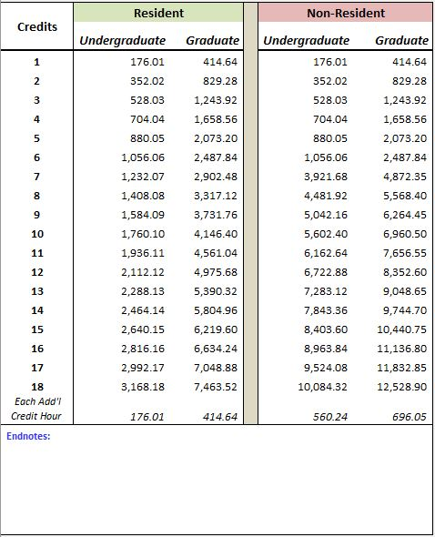
Oregon Tech–Klamath Falls – 2017-18 Academic Year

Mandatory Fees-Klamath Falls
Per Term

The mandatory fees included in the following schedule are applicable to all Oregon Tech - Klamath Falls Campus students and should be added to the applicable tuition charges (based on class-level and total credits) to determine total tuition and fees. In addition, institutions may charge additional fees for specific courses (lab fees, etc.) and services (parking, etc.) Contact the campus directly for information regarding any additional fees.

Note: The following mandatory fees are not applicable to Oregon Tech shared campus programs. The mandatory fees applicable to those programs are included on their respective tuition and fee schedules.

Credits | Building |  |  | Incidental |  |  | Health Service |  |  | Total Fees
 | Undergraduate | Graduate |  | Undergraduate | Graduate |  | Undergraduate | Graduate |  | Undergraduate | Graduate
1 | 23.00 | 23.00 |  | 182.50 | 182.50 |  | - |  |  | 205.50 | 205.50
2 | 25.00 | 25.00 |  | 182.50 | 182.50 |  | - |  |  | 207.50 | 207.50
3 | 27.00 | 27.00 |  | 182.50 | 182.50 |  | - |  |  | 209.50 | 209.50
4 | 29.00 | 29.00 |  | 182.50 | 182.50 |  | - |  |  | 211.50 | 211.50
5 | 31.00 | 31.00 |  | 182.50 | 182.50 |  | - |  |  | 213.50 | 213.50
6 | 33.00 | 33.00 |  | 345.00 | 345.00 |  | 150.00 | 150.00 |  | 528.00 | 528.00
7 | 35.00 | 35.00 |  | 345.00 | 345.00 |  | 150.00 | 150.00 |  | 530.00 | 530.00
8 | 37.00 | 37.00 |  | 345.00 | 345.00 |  | 150.00 | 150.00 |  | 532.00 | 532.00
9 | 39.00 | 39.00 |  | 345.00 | 345.00 |  | 150.00 | 150.00 |  | 534.00 | 534.00
10 | 41.00 | 41.00 |  | 345.00 | 345.00 |  | 150.00 | 150.00 |  | 536.00 | 536.00
11 | 43.00 | 43.00 |  | 345.00 | 345.00 |  | 150.00 | 150.00 |  | 538.00 | 538.00
12 or more | 45.00 | 45.00 |  | 345.00 | 345.00 |  | 150.00 | 150.00 |  | 540.00 | 540.00
Endnotes:
(1) Klamath Falls campus Health Service Fee is optional for 1-5 credits, if option is exercised the fee is $150 per term.
(2) In lieu of Oregon Tech enrollment fees students enrolled in the Chemeketa Dental Hygiene program will be assessed at Chemeketa Community College rates.
(3) Students in upper division health service curriculums and international students are required to carry major medical insurance.
(4) A one-time non-refundable a $40 Transcript for Life Fee is assessed on all new and transfer students.A one-time non-refundable Matriculation Fee of $300 for undergraduate and $150.00 for graduate students is assessed on allnew and transfer students.
(5) Qualified tuition and fees do not include student health related fees or student insurance for Tax Relief Act reporting.

Oregon Tech–Klamath Falls – 2017-18 Academic Year

Differential Programs—Undergraduate
Per Term

Data in this table represents Tuition Costs only and does not include Mandatory Fees. The Mandatory Fee information can be found in the Mandatory Fee Tables for this institution.

Allied Health

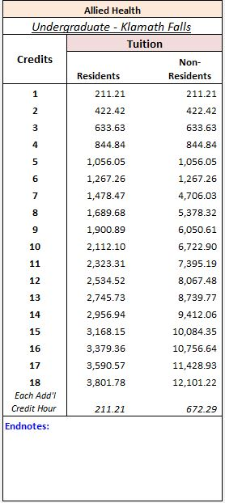

Oregon Tech–Klamath Falls – 2017-18 Academic Year

Differential Programs—Undergraduate
Per Term

Data in this table represents Tuition Costs only and does not include Mandatory Fees. The Mandatory Fee information can be found in the Mandatory Fee Tables for this institution.

Engineering & Technology

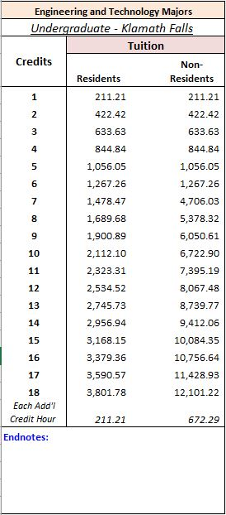

Oregon Tech–Klamath Falls – 2017-18 Academic Year

Differential Programs—Graduate
Per Term

Data in this table represents Tuition Costs only and does not include Mandatory Fees. The Mandatory Fee information can be found in the Mandatory Fee Tables for this institution.

Engineering & Technology

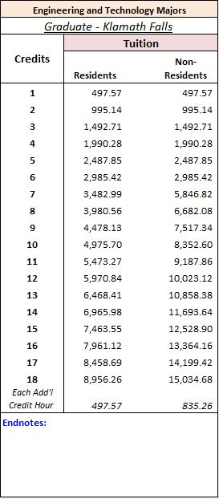

Oregon Tech–Shared Campus Programs – 2017-18 Academic Year

Per Term

Medical Lab Science–OHSU

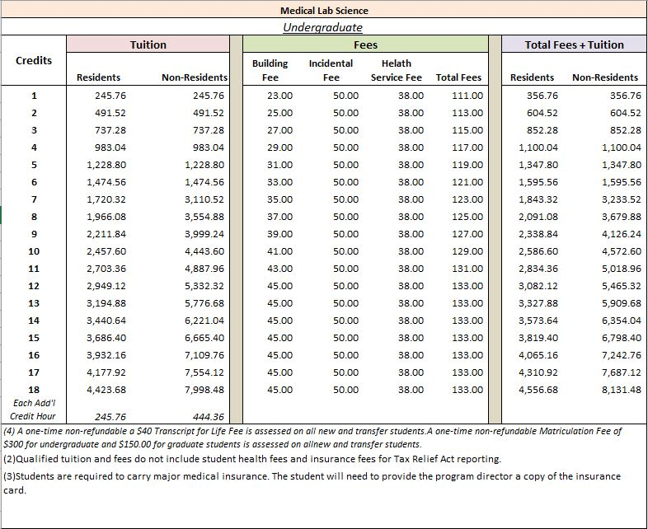

Oregon Tech-Shared Campus Programs – 2017-18 Academic Year

Per Term

Paramedic Education–OHSU

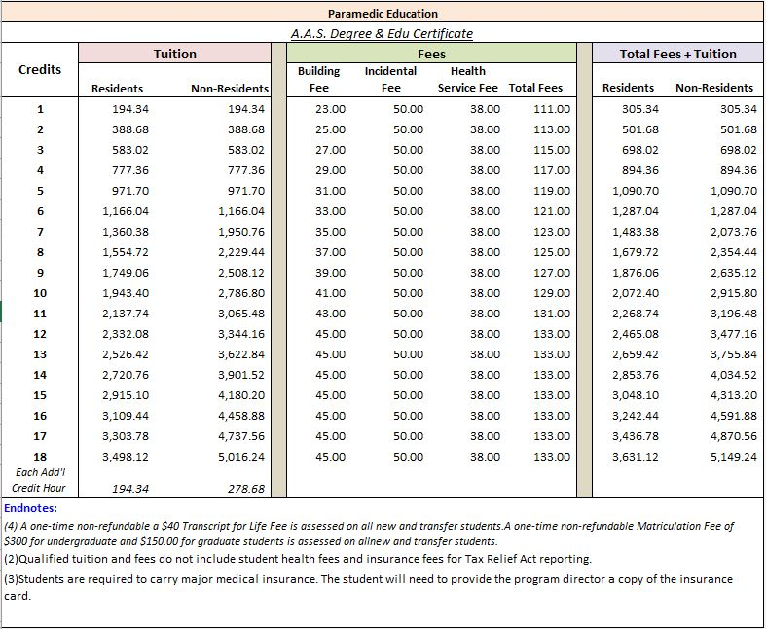

Oregon Tech—Wilsonville – 2017-18 Academic Year

Base Tuition
Per Term

Data in this table represents Tuition Costs only and does not include Mandatory Fees. The Mandatory Fee information can be found in the Mandatory Fee Tables for this institution.

Oregon Tech—Wilsonville – 2017-18 Academic Year

Mandatory Fees
Per Term

The mandatory fees included in the following schedule are applicable to all Oregon Tech - Wilsonville Campus students and should be added to the applicable tuition charges (based on class-level and total credits) to determine total tuition and fees. In addition, institutions may charge additional fees for specific courses (lab fees, etc.) and services (parking, etc.) Contact the campus directly for information regarding any additional fees.

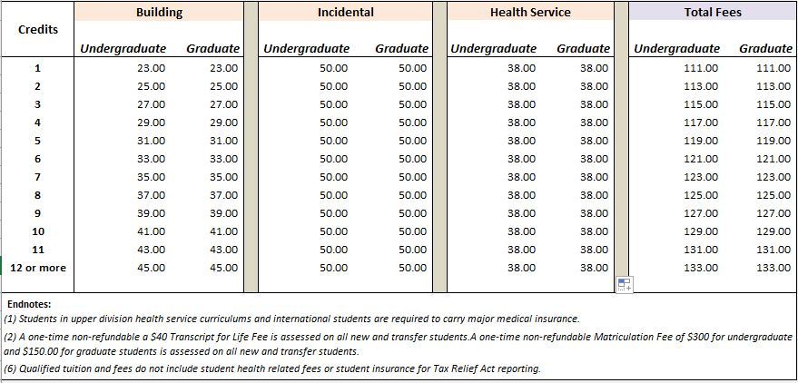

Oregon Tech—Wilsonville – 2017-18 Academic Year

Differential Programs—Undergraduate
Per Term

Data in this table represents Tuition Costs only and does not include Mandatory Fees. The Mandatory Fee information can be found in the Mandatory Fee Tables for this institution.

Allied Health

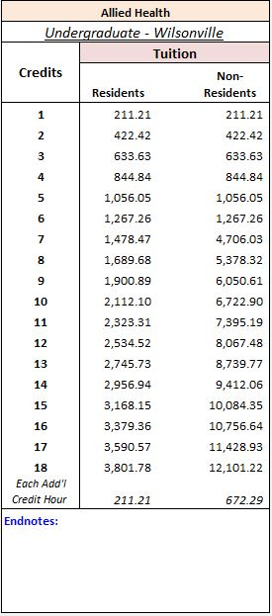

Oregon Tech—Wilsonville – 2017-18 Academic Year

Differential Programs—Undergraduate
Per Term

Data in this table represents Tuition Costs only and does not include Mandatory Fees. The Mandatory Fee information can be found in the Mandatory Fee Tables for this institution.

Engineering & Technology

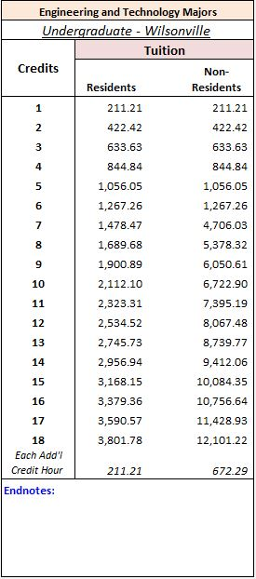

Oregon Tech—Wilsonville – 2017-18 Academic Year

Differential Programs—Graduate
Per Term

Data in this table represents Tuition Costs only and does not include Mandatory Fees. The Mandatory Fee information can be found in the Mandatory Fee Tables for this institution.

Engineering & Technology

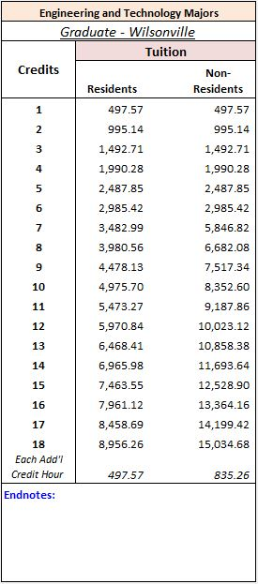

Oregon Tech–Klamath Falls – Summer 2018

Base Tuition
Per Term

Data in this table represents Tuition Costs only and does not include Mandatory Fees. The Mandatory Fee information can be found in the Mandatory Fee Tables for this institution.

Oregon Tech–Klamath Falls – Summer 2018

Mandatory Fees
Per Term

The mandatory fees included in the following schedule are applicable to all Oregon Tech - Klamath Falls Campus students and should be added to the applicable tuition charges (based on class-level and total credits) to determine total tuition and fees. In addition, institutions may charge additional fees for specific courses (lab fees, etc.) and services (parking, etc.) Contact the campus directly for information regarding any additional fees.

Note: The following mandatory fees are not applicable to Oregon Tech shared campus programs. The mandatory fees applicable to those programs are included on their respective tuition and fee schedules.

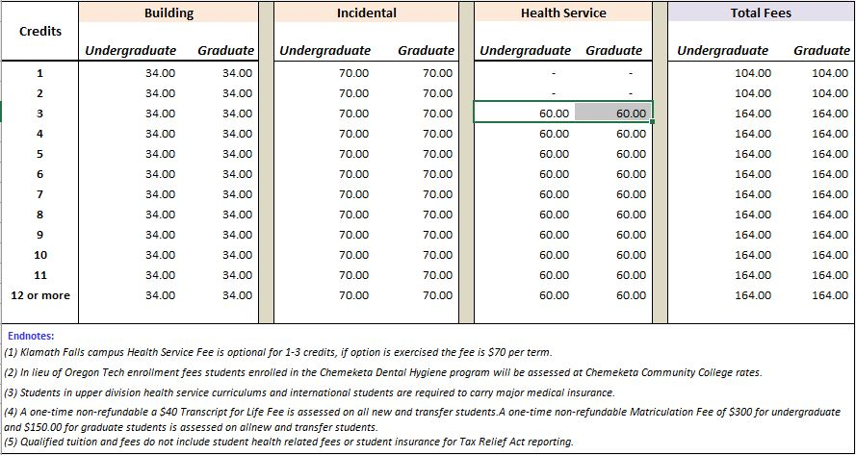

Oregon Tech–Klamath Falls – Summer 2018

Differential Programs—Undergraduate
Per Term

Data in this table represents Tuition Costs only and does not include Mandatory Fees. The Mandatory Fee information can be found in the Mandatory Fee Tables for this institution.

Allied Health

Oregon Tech–Klamath Falls – Summer 2018

Differential Programs—Undergraduate
Per Term

Data in this table represents Tuition Costs only and does not include Mandatory Fees. The Mandatory Fee information can be found in the Mandatory Fee Tables for this institution.

Engineering & Technology

Oregon Tech–Klamath Falls – Summer 2018

Differential Programs—Graduate
Per Term

Data in this table represents Tuition Costs only and does not include Mandatory Fees. The Mandatory Fee information can be found in the Mandatory Fee Tables for this institution.

Engineering & Technology

Oregon Tech–Shared Campus Programs – Summer 2018

Per Term

Medical Lab Science–OHSU
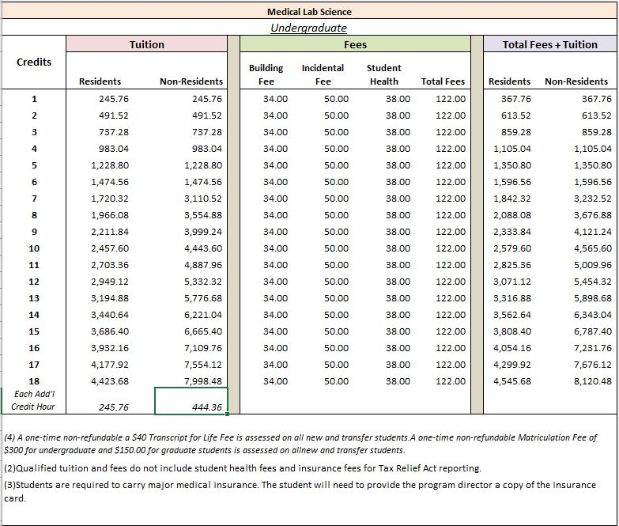

Oregon Tech-Shared Campus Programs – Summer 2018

Per Term

Paramedic Education–OHSU
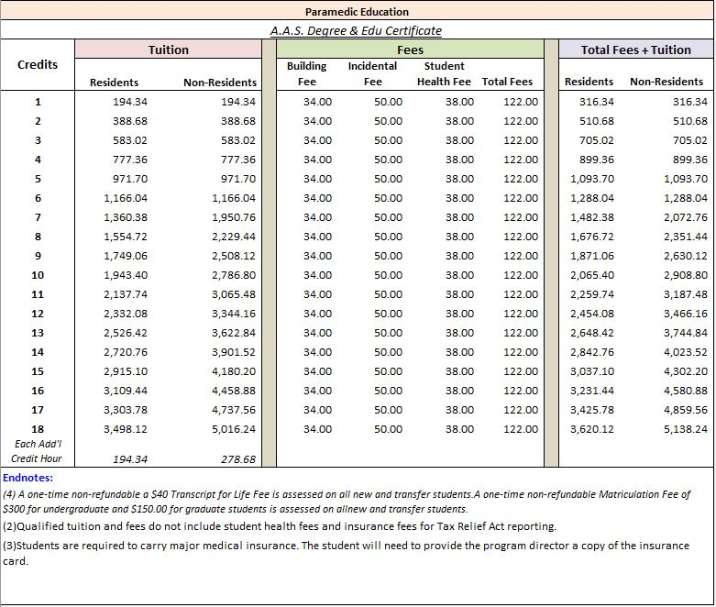

Oregon Tech–Wilsonville – Summer 2018

Base Tuition
Per Term

Data in this table represents Tuition Costs only and does not include Mandatory Fees. The Mandatory Fee information can be found in the Mandatory Fee Tables for this institution.

Oregon Tech–Wilsonville – Summer 2018

Mandatory Fees
Per Term

The mandatory fees included in the following schedule are applicable to all Oregon Tech - Wilsonville Campus students and should be added to the applicable tuition charges (based on class-level and total credits) to determine total tuition and fees. In addition, institutions may charge additional fees for specific courses (lab fees, etc.) and services (parking, etc.) Contact the campus directly for information regarding any additional fees.
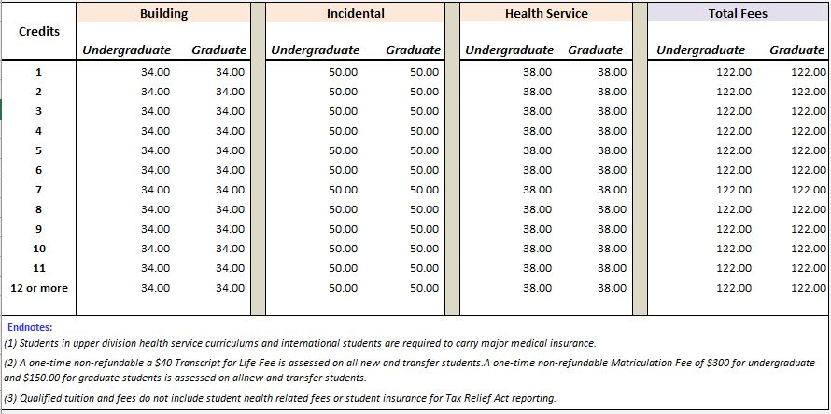

Oregon Tech–Wilsonville – Summer 2018

Differential Programs—Undergraduate
Per Term

Data in this table represents Tuition Costs only and does not include Mandatory Fees. The Mandatory Fee information can be found in the Mandatory Fee Tables for this institution.

Allied Health

Oregon Tech–Wilsonville – Summer 2018

Differential Programs—Undergraduate
Per Term

Data in this table represents Tuition Costs only and does not include Mandatory Fees. The Mandatory Fee information can be found in the Mandatory Fee Tables for this institution.

Engineering & Technology

Oregon Tech–Wilsonville – Summer 2018

Differential Programs—Graduate
Per Term

Data in this table represents Tuition Costs only and does not include Mandatory Fees. The Mandatory Fee information can be found in the Mandatory Fee Tables for this institution.

Engineering & Technology

Glossary of Terms

Glossary of Terms Common to Higher Education
Academic advisement: Each admitted student is assigned to a faculty member or a trained adviser who helps the student create and implement a plan, via regularly scheduled meetings, to attain short- and long-term academic and vocational goals.
Admitted student: Applicant who is offered admission to a degree-granting program at Oregon Institute of Technology (Oregon Tech).
Applicant (first-time, first-year): An individual who has fulfilled the institution's requirements to be considered for admission (including payment or waiving of the application fee, if any) and who has been notified of one of the following actions: admission, non-admission, placement on waiting list, or application withdrawn (by applicant or institution).
Application fee: That amount of money an institution charges for processing a student's application for acceptance. This amount is not creditable toward tuition and required fees, nor is it refundable if the student is not admitted to the institution.
Application fee deferral: The application fee for first-time freshmen or transfer students may be deferred for students who meet specific requirements.
Articulation: The process by which two or more institutions align courses and programs to ensure the smooth flow of students between campuses.
Associate degree: An award that normally requires at least two but less than four years of full-time equivalent college work.
Bachelor's degree: An award (baccalaureate or equivalent degree, as determined by the Secretary of the U.S. Department of Education) that normally requires at least four years to complete.
Board rates (charges): Cost for a predetermined number of meals per week: generally within a meal plan.
Building fee: A legislatively mandated fee which is assessed at the same rate for all public universities, on a per term basis, to finance debt service for construction associated with student centers, health centers, and recreational facilities.
Calendar system: The method by which an institution structures most of its courses for the academic year.
Career counseling: A range of services that may include: coordination of visits of employers to campus; aptitude and vocational testing; interest inventories; personal counseling; help in résumé writing, interviewing, launching the job search; listings for those students desiring employment and those seeking permanent positions; establishment of a permanent reference folder; and career resource materials.
Class rank: The relative numeric position of a student in his or her graduating class, calculated on the basis of grade point average, whether weighted or un-weighted.
Continuous basis (for program enrollment): A calendar system classification that is used by institutions that enroll students at any time during the academic year.
Community college transfer student: For Oregon Tech, “transfer students" must have completed a minimum number of credits for acceptable college level work.
Credit: A unit of recognition of attendance or performance in an instructional activity (course or program) that can be applied by a recipient toward the requirements for a degree, diploma, certificate, or other formal award.
Credit course: A course that, if successfully completed, can be applied toward the number of courses required for achieving a degree, diploma, certificate, or other formal award.
Credit hour: A unit of measure representing an hour (50 minutes) of instruction over a 10-week period within a quarter system. It is usually applied toward the total number of hours needed for completing the requirements of a degree, diploma, certificate, or other formal award.
Deferred admission: The practice of permitting admitted students to postpone enrollment for a specific period-of-time, for example one academic term or one academic year.
Differential tuition: Differential tuition is defined as additional tuition that is supplementary to the base tuition level approved annually by the Board of Trustees. Differential tuition is intended to 1) offset higher than average instructional costs; or 2) provide supplemental resources to enhance program quality; or 3) reflect the market for programs with high demand. Note: Amounts included in the differential tuition schedules in this document represent the sum of the base tuition and the applicable differential amount.
Degree: An award conferred by a college, university, or other postsecondary education institution as official recognition for the successful completion of a program of studies.
Degree-seeking students: Students enrolled in courses for credit who are recognized by the institution as seeking a degree or formal award. At the undergraduate level, this is intended to include students enrolled in vocational or occupational programs.
Delegation of authority: The Oregon statutes which grant authority to the Oregon Tech Board of Trustees to set tuition and fee rates for Oregon Tech through an established rulemaking process.
Distance education: An option for earning course credit at off-campus locations via cable television, Internet, satellite classes, videotapes, correspondence courses, or other means.
Doctoral degree: The highest award a student can earn for graduate study.
Double major: Completion of two undergraduate programs of study simultaneously.
Fee remission: The fee remission is a means by which a student’s fees are assessed at the prescribed tuition rate and offset by funds from some other source.
First-time student: A student attending any institution for the first time. Includes students enrolled in the WINTER & SPRING TERMS who attended a postsecondary institution for the first time at the same level in the prior summer term. Also includes students who entered with advanced standing (college credit earned before graduation from high school).
First-time, first-year (freshman) student: A student attending any institution for the first time at the undergraduate level. Includes students enrolled in the WINTER & SPRING TERMS who attended college for the first time in the prior summer term. Also includes students who entered with advanced standing (college credits earned before graduation from high school).
Freshman: A first-year undergraduate student.
Freshman/new student orientation: Orientation addressing the academic, social, emotional, and intellectual issues involved in beginning college. May be a few hours or a few days in length. There is commonly a fee associated with this program.
Full-time student (Undergraduate): A student enrolled for 12 or more quarter credit hours.
Geographical residence (as an admission factor): Special consideration in the admission process given to students from a particular region, state, or country of residence.
Grade point average (GPA): The sum of grade points a student has earned divided by the number of courses taken. The most common system of assigning numbers to grades counts four points for an A, three points for a B, two points for a C, one point for a D, and zero points for an I, W, P, or F.
Graduate assistant: Qualified students who are participating in a post-baccalaureate program and who have been appointed by an institution to assist in teaching courses.
Graduate student: A student who holds a bachelor's or first professional degree, or equivalent, and is taking courses at the post-baccalaureate level.
Health services: Low cost, on-campus, health care available to all full-time admitted students as well as part-time students who choose to exercise this option.
Health services fee: This fee provides for each institution’s student health services, which are operated similarly to self-supported auxiliary services.
High school diploma or recognized equivalent: A document certifying the successful completion of a prescribed secondary school program of studies, or the attainment of satisfactory scores on the Test of General Educational Development (GED), or another state specified examination.
Home institution: Institution to which the student is formally admitted and matriculated in a degree program, regardless of where the student is enrolled. In the case where the student is working toward degrees from two institutions within the Oregon University System at the same time, either institution may be considered the home institution.
Honors program: Any special program for accomplished students offering the opportunity for educational enrichment, independent study, acceleration, or some combination of these.
Host institution: Institution to which the student is taking coursework necessary to complete a degree program which is unavailable at the home institution.
Incidental fee: This fee is assessed to provide support for student activities. Student committees make recommendations for the amount and use of the fee on each campus.
In-state tuition: See Resident tuition.
International students: See Nonresident tuition.
Internship: Any short-term, supervised work experience usually related to a student's major field, for which the student earns academic credit. The work can be full- or part-time, on- or off-campus, paid or unpaid.
Mandatory enrollment fees: Fees that are assessed to all full and part-time students as listed in the Academic Year or Summer Session Fee Books. Fees included in this category are: Building, Health Service, Incidental and Recreation Center.
Master's degree: An award that requires the successful completion of a program of study beyond the bachelor's degree.
Nonresident tuition: The tuition charged by institutions to those students who do not meet Oregon residency requirements.
On-campus day care: Licensed day care for students' children (usually age 3 and up); usually for a fee.
Open enrollment: Enrollment for course credits that is available to all qualified students (it is understood that enrollment in certain courses may be subject to requirements e.g., successful completion of prerequisites, grade point average, instructor’s consent, etc.).
Other expenses (costs): Includes average costs for clothing, laundry, entertainment, medical (if not a required fee), and furnishings.
Out-of-state tuition: See Nonresident tuition.
Part-time student (Undergraduate): A student enrolled for 1-8 credit hours per quarter.
Part-time fee policy: Students enrolled under the part-time student fee policy are subject to the mandatory or course fees appropriate to specific courses taken.
Per Term: A term is equal to one academic quarter.
Public institution: An educational institution whose programs and activities are operated by publicly elected or appointed officials, and which is supported by public funds.
Public universities: As defined by ORS 352.002:
- University of Oregon
- Oregon State University
- Portland State University
- Oregon Institute of Technology
- Western Oregon University
- Southern Oregon University
- Eastern Oregon University
Quarter calendar system: An academic calendar system in which the instructional year consists of three academic sessions, called quarters, usually consisting of 10-12 weeks each.
Required fees: Fixed sum charged to all students for items not covered by tuition. These fees do not include fees or optional fees such as lab fees or parking fees.
Resident tuition: The tuition charged by institutions to those students who meet state or institutional residency requirements.
Summer session: A summer session is generally shorter than a regular academic quarter and not considered part of the academic year. An institution may have 2 or more sessions occurring in the summer months.
Tax Relief Act Reporting: The Taxpayer Relief Act, enacted in 1997, provides a tax benefit deduction of interest assessed on education loans for students and their families. The Relief Act specifically excludes books, student health insurance, room and board, and other incidental expenses.
Transfer applicant: An individual who has fulfilled the institution's requirements to be considered for admission (including payment or waiving of the application fee, if any) and who has previously attended another college or university and earned college level credit.
Transfer student: A student entering the institution for the first time but known to have previously attended a postsecondary institution at the same level (e.g., undergraduate). The student may transfer with or without credit.
Tuition: Amount of money charged to students for instructional services. Tuition may be charged per term, per course, or per credit hour.
Undergraduate: A student enrolled in a bachelor's degree program, an associate degree program, or a vocational or technical program.
Wait list: List of students who meet the admission requirements but will only be offered a place in the class if space becomes available.

