South Metro – Salem

Science, Technology, Engineering, and Mathematics (STEM)

Education Partnership

Business Plan V5.5

DRAFT

Section One: Overview

About the South Metro–Salem STEM Education Partnership
The South Metro–Salem (SMS) STEM Education Partnership is a collaborative of 13 school districts, three community colleges, three universities, five community-based STEM programs, and 10 business partners who share a common vision to engage students in Science Technology Engineering and Math (STEM). The South Metro-Salem STEM Partnership catalyzes Oregon students to achieve STEM degrees and certificates, and reach Oregon’s education goals by increasing the access, excitement and engagement of students in STEM courses and experiential learning. The goal of this collective effort is to accelerate STEM learning with the outcome of increasing the pipeline that feeds into the STEM workforce.

About this Document
This business plan describes proven strategies for transforming science, technology, engineering, and mathematics (STEM) education in K-20 schools. It builds on collective impact partnerships, leveraging cross-sector coordination that will engage a community of STEM stakeholders in an intentional and transparent process to improve STEM teaching and learning across partner school districts.

The South Metro – Salem STEM education partnership outlined in this business plan has been conceived as a regional initiative involving local school districts, higher education, business/industry, and community groups. The planned geographic scope for the partnership’s work is south of the Portland metropolitan area along Interstate 5 covering a large and diverse section of the Northern Willamette Valley including the Salem Keizer area.

As a collective impact partnership, the South Metro-Salem STEM Partnership has chosen not to form a new not-for-profit organization at this time, but to leverage the non-profit status and expertise of its members on behalf of the whole partnership. For each of the major activities in the business plan, one of partners will be the lead organization, fiscal agent, and accountable entity for grant proposals, contracts, and fundraising. For example, the STEM Partnership is forming a regional STEM NETwork, with NASA Space Grant Foundation and Evergreen Aviation and Space Museum as the lead entities. The STEM NETwork will create connections between the regional business and community-based resources, and the schools, teachers and students within the partnership. Evergreen Aviation and Space Museum will provide a physical and virtual location for the STEM NETwork. Other partners will take leadership roles to advance additional innovations and best practices in STEM education.

All of the STEM Partnership’s work will be aligned with a coherent statewide system of rigorous college/career-readiness standards, clear outcome targets, and accountability measures.

About Education Reform in Oregon
Recent legislation created the Oregon Education Investment Board (OEIB) to set policy and distribute funding for all public education. The OEIB, chaired by the governor, is charged with overseeing efforts to create a seamless, unified system for investing in and delivering public education. The legislated goal for Oregon’s public investment in education is to ensure that by the year 2025:
- 40 percent of adult Oregonians have earned a bachelor’s degree or higher;
- 40 percent of adult Oregonians have earned an associate degree or postsecondary credential as their highest level of education attainment; and
- 20 percent of all adult Oregonians have earned at least a high school diploma, an extended or modified high school diploma, or the equivalent of a high school diploma as their highest level of educational attainment.

Section Two: South Metro - Salem STEM Education Partnership

Mission Statement
The South Metro-Salem STEM partnership will collectively optimize PK-20 STEM education by utilizing a full spectrum of public and private resources and model instructional practices to develop a career-ready, diverse, and adaptable workforce that enhances the regional economy and community.

The Partnership will engage schools where emphases on STEM learning and teaching will produce a measurable increases in the college and career readiness of PK-20 students, including traditionally underrepresented populations. The partnership will achieve its mission in three strategic ways:
- Building a STEM NETwork – a clearinghouse or virtual connecting place to connect business and community resources with schools and teachers.
- Forming a learning community to identify effective practices among the school districts and community partners, and training teachers in effective instructional practices through proficiency-based teaching and learning, as well as contextualized, experience-based teaching and learning methods.
- Expanding collaborations between schools, colleges and universities to accelerate dual credit in STEM subjects while in high school and better transitions for students into STEM majors and career paths.

The partnership advances Oregon’s 40-40-20 goal and vision for students to achieve college and career readiness. Our goals and expected outcomes by 2025 include:
- By 2025, double the percentage of the region’s 4th, 8th, and 12th graders that are “proficient” and “advanced” as measured by the NAEP.
- By 2025, double the number of STEM college graduates that matriculate from SMS partner schools.
- Increase STEM participation, persistence, and achievement based on ethnic/cultural and/or socioeconomic background, limited English language proficiency, gender, or disability.
- Improve Oregon business and industry access to an Oregon-educated STEM talent pool that is highly skilled, motivated and globally competitive.

Our hope is that this new direction offers to the student, a promise; to the educator, an invitation to lead; to the taxpayers, a return on investment; and to legislators, employers, community leaders, and educational organizations, a new partnership for educational achievement in Oregon.

Section Three: Strategies and Activities

STEM NETwork - connects business and community resources to schools at all levels. The partnership operates in support of Oregon’s 40-40-20 goal for public education.
Learning Community & Professional Development – design and implement professional development to transform learning and teaching so that all students—regardless of background, circumstances, and future aspirations—experience STEM programming that keeps them on a successful pathway to college and career readiness.
Accelerated Credits – connects students with dual credit and secures persistence in STEM careers.
Metrics and evaluation – common set of measurements will help build a regional community of practice focused on the collection, analysis, and reporting of STEM education data across instructional contexts, leading to identification of effective interventions. These common measures will also support more effective knowledge transfer across diverse educational settings.

Strategy: SMS STEM NETWork

The STEM NETwork brings experiential learning, plus excitement and engagement into regional classrooms and schools. The STEM NET builds bridges between the rich resources in our local community, and the schools, teachers and students who are seeking relevant, hands-on, career-focused, experiences that help students envision how their academic learning relates to their future career plans.
The STEM NETwork is envisioned as both a physical and virtual location. Using a tool called CIS Connection (part of the Career Information System that is already available in over 80% of Oregon schools), the STEM NET will license CIS Connection software so that businesses and community partners can offer opportunities for relevant experiences to teachers/students, and teachers can seek the applied learning experiences that are relevant for their lesson plans. Using the CIS Connection electronic tools, businesses can post their availability to be a guest speaker, offer job shadows, or attend a career fair to schools. Teachers can ask for guest speakers, interview coaches or internships. Their needs will be matched in the electronic system, saving time and frustration.
http://www.cisconnection.org/
The SMS STEM Partnership has raised funds, through grants and partner contributions, to hire a STEM NET Director and will apply for grants to pay for the CIS Connection license. The Director will be responsible for helping to populate the electronic system, with robust business and community experiential learning opportunities for schools, and to engage the 13 school districts, and their teachers in using the system to connect business and community resources to their classrooms and students.
The STEM NET Director position will be filled in the fall of 2013. The SMS STEM Partnership is seeking support from the state of Oregon and local workforce investment boards to pay for the licenses to host the CIS Connection for the SMS STEM Partnership and for partnerships and regions around the state.
Hosted by Evergreen Aviation and Space Museum, and the Oregon NASA Space Grant Consortium, both SMS STEM Partners, the STEM NETwork will:
- Build and maintain on-going relationships with SMS STEM partners (K-12, higher education, informal education, industry).
- Bring partners together on a regular basis to develop a short and long range plan for the SMS STEM Network.
- Oversee the implementation of SMS STEM Network-sponsored programs.
- Maintain SMS STEM Network online resources and create a comprehensive catalog and asset map of STEM activities and resources within the region that can be shared and promoted.
- Collaborate with organizations that offer complementary services and match community resources to educators needs.
- Align STEM Network activities with Common Core State Standards and Next Generation Science Standards.
- Build capacity of volunteers to provide meaningful classroom experiences for students, tied to learning outcomes, and build capacity of teachers to align volunteer activities with curriculum.
- Collaborate with other committees within the SMS STEM Partnership to align programming to established objectives, learning outcomes and assessment measures to insure that appropriate education resources are provided to partner educators.
- Collect and analyze assessment data from SMS STEM Network partners; create reports on efficacy of SMS STEM Network programs.

The STEM NETwork will be responsible for supporting STEM improvement, by collecting and disseminating information about evidence-based best practices, and by aggregating learning about best practices that emerges from the experiences of each individual school.

The STEM NETwork will serve as the information and programming hub with primary functions around partnership development, and connecting teachers and students to the world of work through industry mentorships, job shadows and internship opportunities.
The STEM NETwork will also develop the capacity of business and community volunteers to provide meaningful student experiences that support the education curriculum and learning outcomes in the classroom. The NETwork will build the capacity of classroom teachers to utilize volunteers by demonstrating how various types of volunteer activities support the common core state standards.

Proposed Measures (common measures to be determined by education partners by September 2013):
1) % of students taking STEM courses in MS and HS
2) % students taking advanced science and math.
3) number of students involved in STEM programs that are voluntary

As far as STEM NET data goes....
1) number of teachers using STEM NETwork
2) % increase in number of students impacted by experiential learning through the STEM NETwork

Strategy: Collaborative Learning Community and Professional Development

Moving from Isolated Interventions to a Collaborative Learning Community
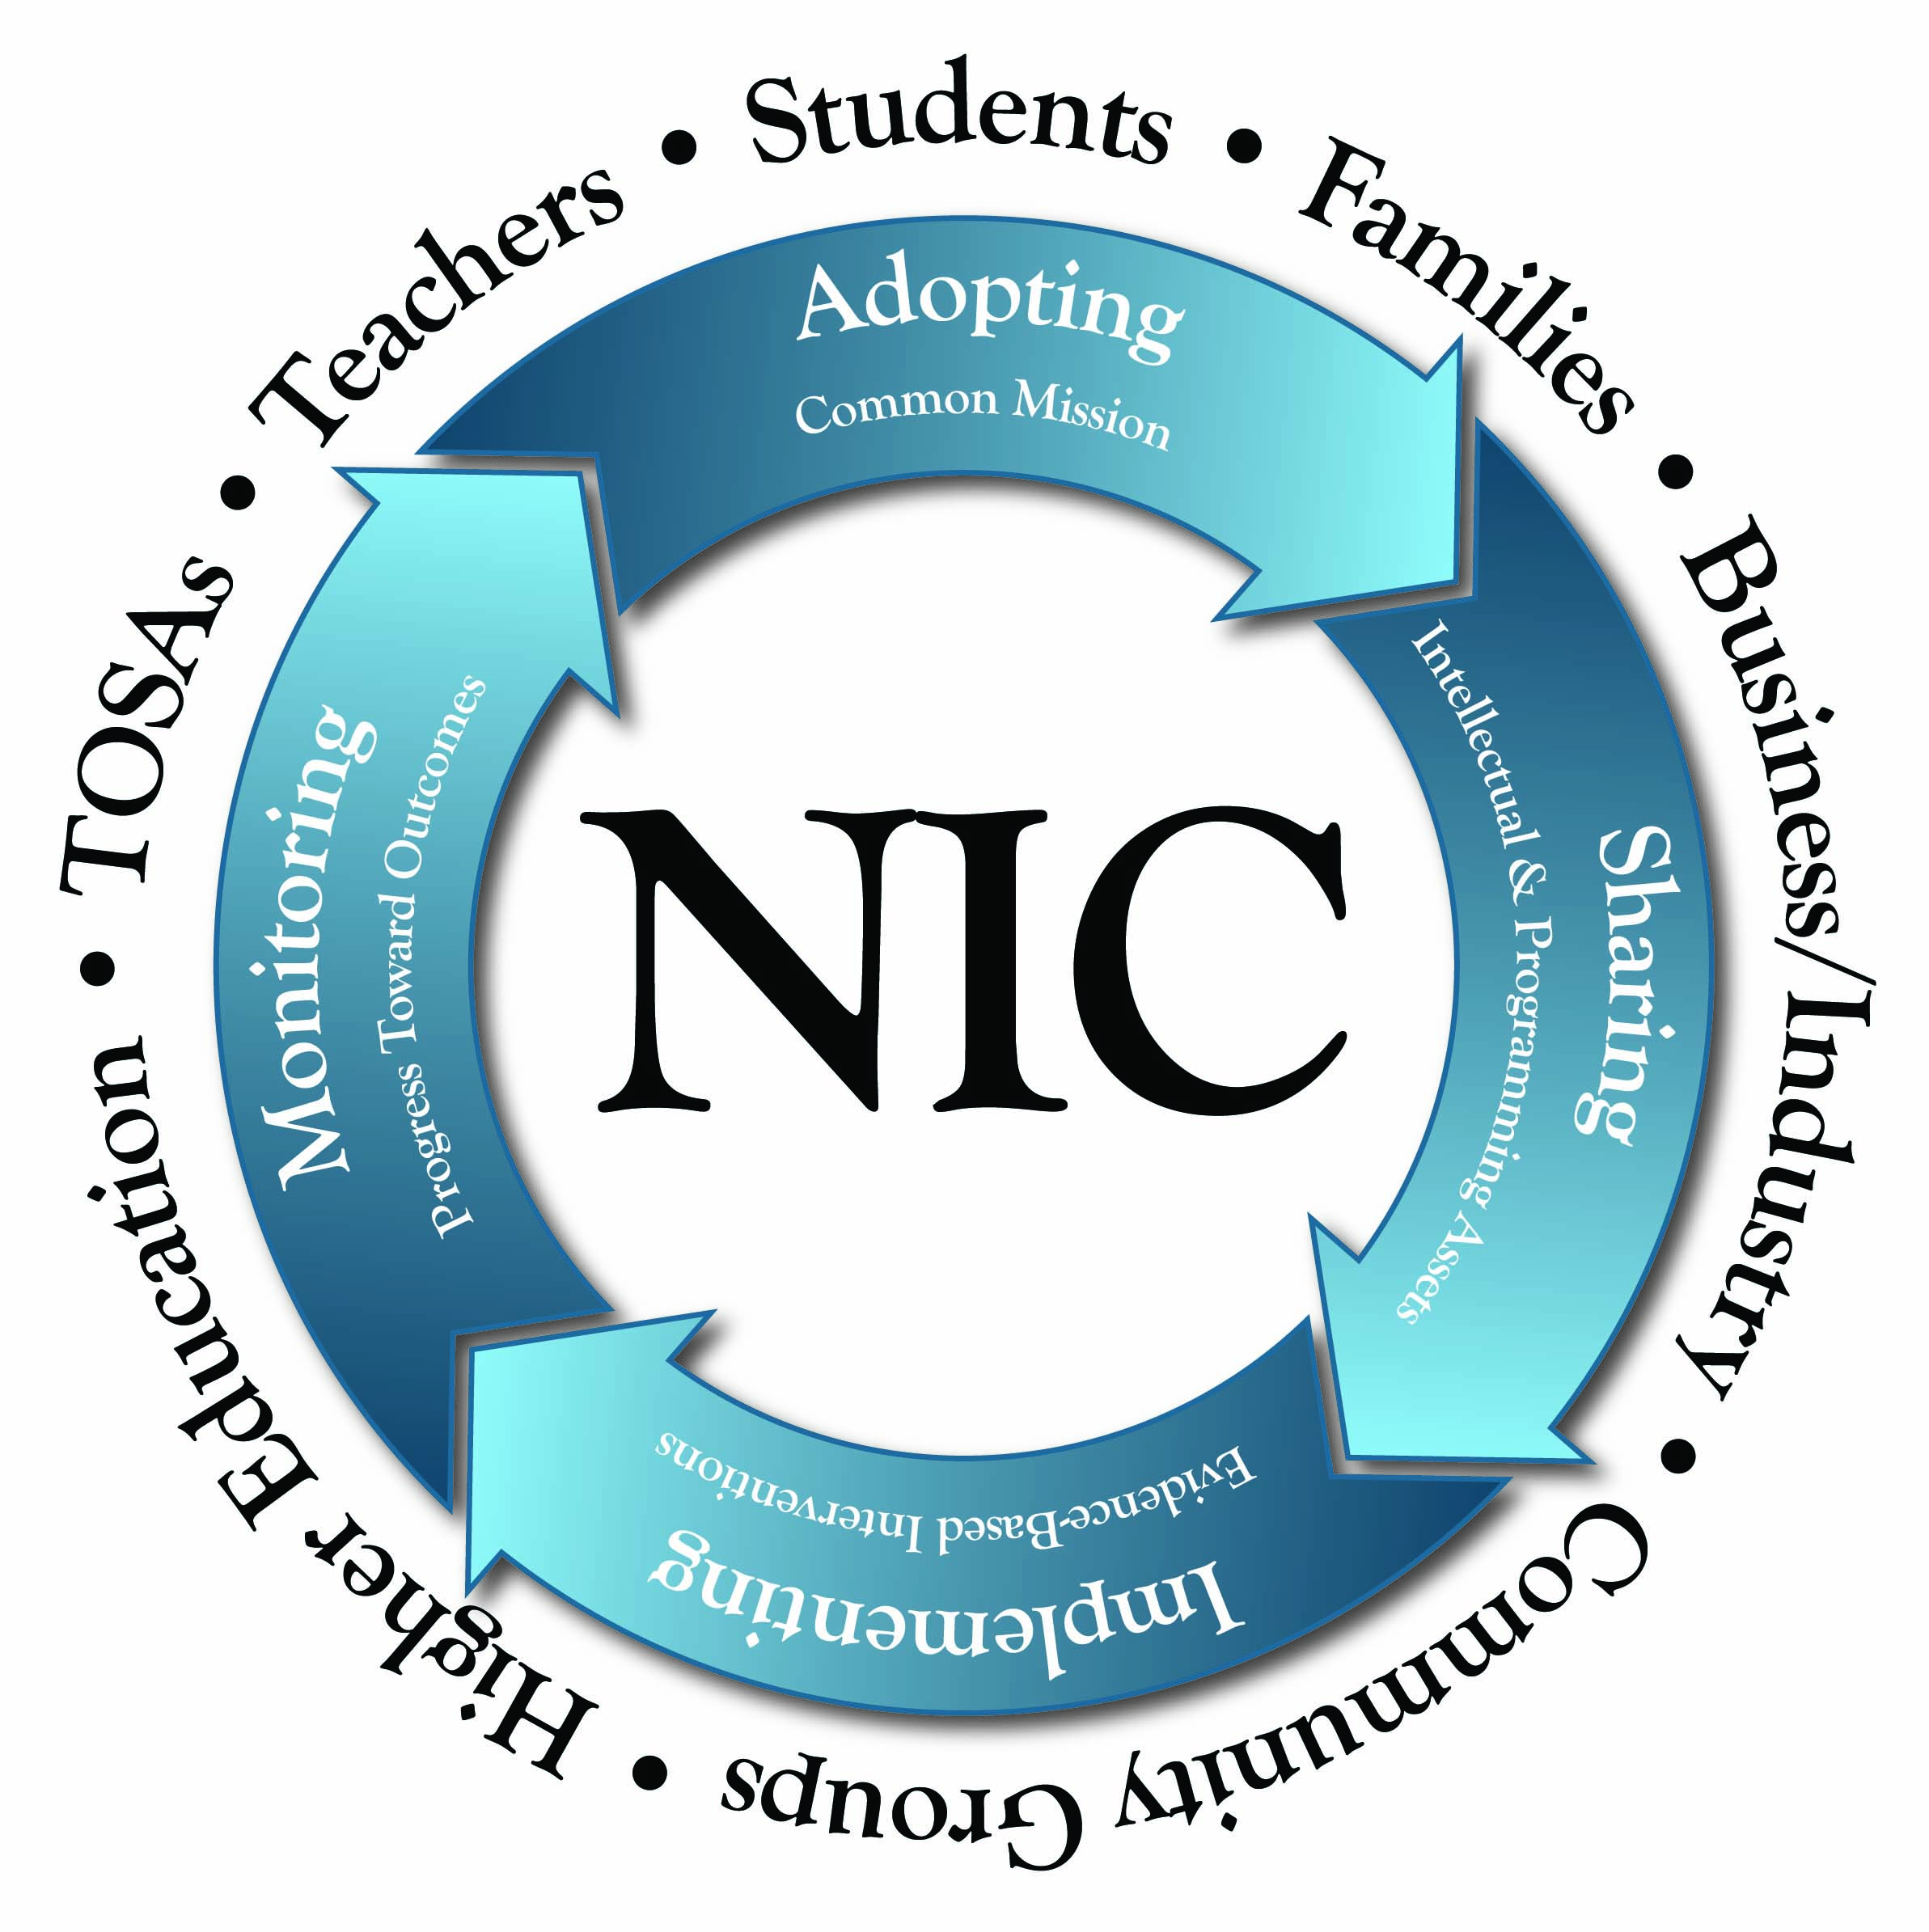
The SMS STEM Partnership brings together varied entities, interests, and expertise into a Collaborative Learning Community. Working together, each partner school district and community partner will contribute to the Learning Community.

The Learning Community is envisioned as a collaboration of teachers and education practitioners, joined together to engage and excite more students in science, technology, engineering and math. Each district in the partnership will identify three teachers or science specialists in their districts, at three education levels – k-5, 6-8, 9-12 – who will join the community of practice, along with informal, community-based practitioners. The community will begin by identifying results-oriented, successful teaching practices and curriculum, and determining ways to share those practices across the 13 partner districts. The LC will also assess gaps in professional development for district teachers, and formulate a plan for shared professional development and approaches that leverages the resources and expertise in partner districts.
The SMS Partnership’s approach aligns with research by the Carnegie Foundation about forming a “Networked Improvement Community,” that includes engagement, outcomes, scale, measurement, disciplined inquiry and accelerated improvements. www.carnegiefoundation.org

Improving STEM education is an economic and civic imperative. Creating a coherent, rigorous, and equitable system of STEM education from pre­kindergarten through high school graduation will help ensure that:
- Oregon students have the knowledge, skills, experience, and enthusiasm needed to enter post­secondary education and high paying, in demand careers in STEM related fields.
- Oregon businesses and industries have access to an Oregon educated STEM talent pool that is highly skilled, motivated, and globally competitive.
- Oregon schools and teachers have the tools and support needed to deliver world-class STEM instruction.
- Oregonians have the scientific literacy and technological knowledge needed to make informed decisions in their personal lives and as citizens to address increasingly complex and interconnected local, national, and global challenges.

STEM Continuum of Practice

Characteristics
STEM education should:
- Integrate the STEM disciplines of science, technology, engineering, and math
- Integrate and deliver both formal and informal STEM learning opportunities for students
- Provide authentic experiences, contextual learning, and career awareness through partnerships with businesses, industries, agencies, and non­profits in the community
- Focus instruction on problem solving and critical thinking skills through inquiry and design
- Include effective instructional strategies that develop collaboration and teamwork
- Develop communication and literacy skills
- Include the use of standards-based performance assessments
- Provide post­secondary and career relevance and connections

Standards to Support STEM Education
- Next Generation Science Standards (NGSS)
- Common Core State Standards (CCSS)
  - English Language Arts
    - Literacy in Science and Technical Subjects
  - Mathematics
The Learning Community of teachers and STEM coaches will utilize this process and their collaborative time together to determine how to increase the effectiveness of their STEM practice while implementing the Next Generation Science Standards and the Common Core State Standards. Learning Community participants will also learn how to integrate informal education and community-based experiences through use of the STEM NETwork.
Ultimately, partners will develop strategic investment plans that are tailored to the school district’s specific needs, challenges, and assets, and are designed to achieve measurable student gains in STEM readiness. The partnership will help secure the resources needed to support STEM programming and targeted interventions at each partner school district.

Proposed Measures:
- Number of teachers participating in STEM professional development (as defined by learning community framework) – survey via superintendents
- Number of teachers who have changed practices: STEM curriculum or project-based learning – survey

Strategy: Accelerated College Credits

Expanded School, College, University collaborations that accelerate students in STEM Colleges and universities in the SMS STEM Partnership are expanding opportunities to provide more students with college credits before they enter college. Students who receive advanced college credits are usually more career-focused and better prepared to successfully complete college course when they transition, and are more likely to enroll in college after high school, so they can “spend” their hard-earned college credits. Advanced college credits, when they satisfy college-level general education or major requirements, can save students time and money.
Chemeketa Community College: College Credit Now Program
College Credit Now (CCN) provides high school students with an opportunity to earn Chemeketa credit while still in high school for only $25 per year. Students can take as many CCN classes as are available to them at their school. There are a wide number of courses available in high schools throughout our region. Over 133 CCN teachers at 32 high schools offer college courses to upwards of 5,540 students each year in the Mid-Willamette Education Consortium region. Chemeketa will work with SMS Partner school districts to expand STEM college credits.
Clackamas Dual Community College Credit Programs
Clackamas Community College offers a variety of ways to earn college credits. If students are still in high school but interested in gaining early college credit, or looking to transfer military training and experience into a degree program, Clackamas can help. There are numerous options available. College Credit Alternatives at CCC Include:
- Advanced College Credit (ACC)
- Advanced Placement (AP)
- College Level Examination Program (CLEP)
- Credit for Prior Learning (CPL)
- International Baccalaureate (IB)
- Military Credit

Portland Community College Dual Credit Programs
High school students in the Portland area are receiving college credits for high school courses through an "articulated credit" program at Portland Community College called PCC Dual Credit. By the time these students graduate from high school they already have a head start on post-secondary education at a cost far below regular college tuition prices, saving both time and money as they get started on their next steps.
Students can earn:
- University Transfer credit that counts toward a Bachelor's degree in such subject areas as Literature, Writing, World Languages, History, Science and Mathematics, or
- Credit in Career & Technical Education, Associate of Applied Science programs, such as Automotive Service Technology, Computer Applications Systems, Early Childhood Education, Welding, Construction and many more!
Two courses are said to be "articulated" when the high school course has the same content and outcomes as the college course. Although taught in the high school, the course materials, content and instructional quality are consistent with (or "articulated" with) courses offered by the community college. Because of that articulation, a student would be able, following high school graduation, to transition smoothly to the next level of college courses in the subject area.
In 2011-12, the PCC Dual Credit program registered 4,284 students who earned 26,243 PCC credits. As a student of the PCC Dual Credit program, students were not charged tuition or fees. This was a savings to the students (and their parents) of $2,073,197 in PCC tuition. PCC hopes to expand access to dual credits through its campuses in the South Metro-Salem area, especially at their Newberg and Sylvania campus service areas.
Oregon Tech Advanced Credit Programs
To expand dual college credits, Oregon Tech has added a staff position to work with partnership schools to identify dual credit opportunities, align course outcomes, identify mentor teachers, and build the systems to make dual credit possible. Oregon Tech is also identifying courses that can be offered to partner districts and students on-campus in Wilsonville, so students who are prepared academically to take college course that are not offered at their high schools have the opportunity to do so at Oregon Tech. Partner community colleges are engaged in similar strategies to award dual credit and to bring students into on-campus college courses.

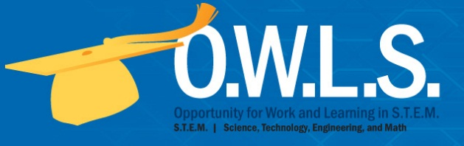
Oregon Tech has also added an incentive scholarship program for students who garner advanced college credits in STEM subjects, prior to their admission to college.
The OWLS program provides a unique scholarship opportunity for Oregon Tech-bound students who obtain at least 9 science, technology, engineering or math (STEM) college credits through dual high school/college credits in their high school, expedited on-site college classes or Project Lead the Way engineering and technology credits by exam. Students who are admitted to Oregon Tech and meet the OWLS criteria receive a one-year $1,000 scholarship. Oregon Tech also offers two $6,000 scholarships to FIRST Robotics students for a total annual investment of $12,000.
Click here for more information about the OWLS program at Oregon Tech.
Oregon Tech works with partner high schools to identify courses that can be offered for dual credit in the Advanced Credit Program (ACP). The courses must meet the standards and outcomes of a college-level course and the teacher must be qualified to teach at the college level. They work with a mentor professor from Oregon Tech. Partner high schools can also arrange for their students to take courses on Oregon Tech’s campuses through High School Transition (HST), or students can demonstrate proficiency at a college level by taking exams in their Project Lead the Way (PLTW) courses. STEM college credits may also be acquired at other accredited colleges and universities that are transferrable to Oregon Tech.
The SMS STEM Partnership intends to expand the number of incentives for students to gain STEM accelerated credits, to increase the level of student preparation and persistence into college-level STEM majors and on to STEM careers.

Proposed Measures:
- Number of dual or accelerated credits in STEM Courses among students in partner districts – common measure
- Number of college-going incentives: scholarships, preferential admissions

Section Four: SMS STEM Action Plan and Timeline

Four-Year Process of Regional Engagement and Transformation in STEM

2012 Phase 0: Envision
  - Establish a shared vision for STEM transformation
  - Sign Partnership Agreement
2013 Phase 1: Plan
  - Develop STEM Partnership Strategic Investment Plan
  - Identify key strategies and work plan
  - Develop common measures
  - Identify funding sources and secure STEM investment commitments
  - Hire STEM NET Director
2014 Phase 2: Build
  - Develop Strategic Investment Plan for each partner district, tailored to the unique challenges and assets of the district
  - Engage Teachers in Learning Community
  - Launch initial teacher professional development
  - Launch STEM NETwork
  - Expand dual credit opportunities
  - Make Infrastructure Investments
  - Aggregate baseline data for common measures
2015 Phase 3: Implement
  - Deliver STEM NETwork programming
  - Showcase effective practices from Learning Community and assess scalability
  - Continue teacher professional development
  - Expand dual credit opportunities
  - Continue STEM Impact measurement

2016 Phase 4: Refine
  - Use assessment data to revise programming
  - Transition to sustainable program partnerships
  - Report on STEM Impacts

Section Five: Partnership Governance and Management Structure

Governance
The SMS STEM Partnership will convene an Executive Advisory Board (EAB) to provide policy direction, leadership, and oversight. All of the core partners in good standing will be represented on the EAB. Board members will elect a Chair at the September 2013 meeting. The Chair will convene a minimum of four board meetings per year and will serve renewable one-year terms.

The SMS STEM Partnership Agreement will define the participation of each of the core partners. The terms of the Partnership Agreement for each core partner will be renewed annually. The founding core partners will be identified by mutual decree. At the annual meeting, Agreements will be submitted to the Oregon STEM Education Executive Advisory Board, which will accept the terms of Agreement and declare the core partner in good standing through a majority vote.

At the quarterly meetings Board members will receive an oral report on the partnership activities, program implementation, and program evaluation. They will make recommendations to inform continuous improvement and long-range planning. At the annual meeting the Board will review a written summary and evaluation of the partnership’s activities and the STEM NETwork’s programming.

Fiscal Authority
- The Oregon State –NASA Space Grant Consortium will serve as the fiscal agent for grants and philanthropic gifts that support the STEM NETwork’s offices and programming.
- Collaborating school districts will serve as fiscal agents for grants and philanthropic gifts that finance the STEM Education Strategic Investment Plans in their schools.
- Partnering colleges and universities will retain administrative and financial authority for the grants and contracts for which their employees serve as principal investigators.

Section Six: Budget and Investment Overview

The South Metro – Salem STEM Education Partnership will execute its business plan through a combination of research and development and school-based transformation activities. The staff, and programming for the STEM NETwork are funded by the core partners through a cost-sharing arrangement from three sources: annual contributions from the partnership’s core business and education partners, grants and contracts that are secured by core and collaborating partners from public and private sources, and revenue generated by partnership activities, such as professional development. All partners will work together to raise funds for collective activities that benefit all members.

All funds: Develop plan, Lead entity for each proposal, and Timeline
Federal Sources | Subject and Lead Applicant | Due Dates
National Science Foundation | develop plan with timelines
Department of Labor | Oregon Tech and CCs to apply for CC-to-university STEM transfers | July 2013
Department of Education
Other sources….
State Sources
Connecting to the World of Work funds HB3232 | - STEM Network – STEM Hub  - STEM/CTE targeting underserved population  - Accelerated Credit for partnership schools | Fall 2013
Professional Development Funds HB3233 | Professional Learning Community and STEM Coaches – Salem-Keizer to be lead applicant | September/Oct 2013 RFP from DOE
STEM Bill HB2636 | STEM Council to be established between July – Dec 2013 | Will influence other state funding
Private Sources
Eaton
FLIR
First Tech Credit Union
Mentor Graphics Foundation
PGE Foundation
Other business partners TBD
Revenue-Generating Activities
Professional development
Other sources

Partnership Investment Plan: Items in Red do not currently have a source of funds.
Strategy | Activity | Comments | Year 1: Funds, In-kind and Source | Year 2: Funds, In-kind and Source | Year 3: Funds, In-kind and Source | Total
STEM Hub | Convene and facilitate strategy work groups; execute business plan | 1 FTE  Currently in-kind by Oregon Tech and FIRST | 125,000 | 130,000 | 135,000 | 390,000
One: Build STEM NETwork | Connect STEM activities to teachers and classrooms (businesses, FIRST, etc.)  STEM NETwork Director  HB3232 State Funds | $75K for 1 FTE  ($50K salary  plus $25K benefits) | NASA Space Grant $42,758  Companies: $17,500  Schools: $14,000  Evergreen Museum:  $25K in-kind | NASA $54,502  Raise school and corporate donations to match  $40,000 | NASA $37,500  Raise school and corporate donations to match  $40,000 | $80,000
 | STEM NETwork Support | Travel expenses and supplies | $10,000 | $10,000 | $10,000 | $30,000
 | CIS Connection | Licensing | 25,000 | 25,000 | 25,000 | $75,000
 | Program Delivery: Programs in Schools | Cost of classroom supplies, transportation | $325,000  Grants | $325,000  Grants | $325,000  Grants | $975,000
 | Align experiential learning with CCSS and NGSS | Consultant | $30,000 | $30,000 | $10,000 | $70,000
Two: Professional Learning Community and Teacher Professional Development | Learning Community of STEM Teachers  30 teachers each year plus leadership training | Identify effective practices:visitations, substitutes, workshops, travel | $77,800  Salem-Keizer SD In-Kind: $12,601 for convening and supplies | $96,550 | $121,550 | 295,900
 | Project Coordinator, STEM Coaches; learning lab; scaling up effective practices | 18 coaches for 13 districts | $1,911,600 | $1,898,872 | $1,935,870 | $5,746,342
Three:  Expand Dual Credit and STEM Pathways | Expand dual credit and high school transitions  Office space, IT, phone for both positions; travel for Academic Agreement position | Office of Academic Agreements Support Position | In kind from OIT: $68,000  Salary, benefits  $20,000 | In kind from OIT: $68,000  Salary, benefits  $20,000 | In kind from OIT: $68,000  Salary, benefits  $20,000
 | Accelerated College Credit Coordinator: | instructor approval, proficiency, credit by exam | 100,000 | 100,000 | 100,000 | $300,000
Program Evaluation | Consultant: common measures, aggregate data, conduct evaluation | Half for learning community and half for overall strategy | $50,000 | $50,000 | $50,000 | $150,000
Admin Fees | NASA Foundation | 4%

Appendix 1 : South Metro-Salem STEM Current Partner List May 2013
Industry Partners
- Autodesk
- Eaton
- First Tech Credit Union
- FLIR Systems
- Garmin AT
- Intel
- Legacy Meridian Park Hospital
- Mentor Graphics
- NASA Space Grant Consortium
- PGE Foundation
- Xerox
Community Partners
- Evergreen Aviation and Space Museum
- Oregon FIRST
- Mad Science of Portland and Vancouver
- Math, Engineering, Science Achievement (MESA)
- Project Lead The Way
- Business Education Compact
- NASA/Oregon Space Grant Consortium
School Districts and ESDs
- Amity School District
- Canby School District
- Gladstone School District
- Lake Oswego School District
- McMinnville School District
- Molalla River School District
- Newberg SD
- North Clackamas School District
- Oregon City School District
- Salem-Keizer School District
- Tigard-Tualatin School District
- West Linn-Wilsonville School District
- Woodburn School District
- Clackamas CTE Consortium
Community Colleges
- Chemeketa Community College
- Clackamas Community College
- Portland Community College- focus on Sylvania and Newberg Campuses
Universities
- Oregon Tech, Pacific University, Western Oregon University

Appendix 2: Executive Advisory Board

Salam Noor Salem Keizer SD
Jeff Clark Amity SD
Chylon Pappas First Tech Credit Union
Boyd Westover Eaton Corp
Craig Hudson Garmin
Kevin Carr Pacific University
Lita Colligan Oregon Tech
Johnny Mack Chemeketa CC
Deb Mumm-Hill Oregon FIRST Robotics
Ed Dennis Project Lead the Way
Stephen Guntli Evergreen Aviation & Space Museum
Rep. John Davis R-Wilsonville
Rep. Betty Komp D-Woodburn

Appendices on Website

South Metro-Salem STEM Partnership Agreement: December 2012
SMS STEM Partnership Agreement Amendment One: April 2013

South Metro-Salem STEM Learning Community Plan: 2013-2016
Meeting Minutes and Agenda

Website: www.oit.edu/stem

